CTCNS Farm Safety Plan USB Guideline
Each of the documents available on the USB are compliant to Occupational Health and Safety Act & Regulation requirements, and are transferrable to farms. Farms should read through each document and edit them to reflect the specific farm activities such as persons doing specific activities, schedules, locations, phone numbers, etc…
Farms are required to add their farm name to each document and will need to remove the Farm Safety Nova Scotia disclaimer at the bottom of each document.
Recommend copying the files on the USB to another location and use the files in the new location as your working documents and keeping the USB as originals and a backup if all goes wrong.
How to Make the Documents Your Own:
Each of the USB documents are fillable templates meaning the farm name can be entered under the document properties and then self-populate in the document when it is updated. This will save a lot time typing in the farm name on each form.
The directions to do this are as follows:
- Open the required document.
- Click File at the top left of the screen.
- Click Info
- Click Properties on the right-hand side of the window that opened.
- Click Advanced Properties
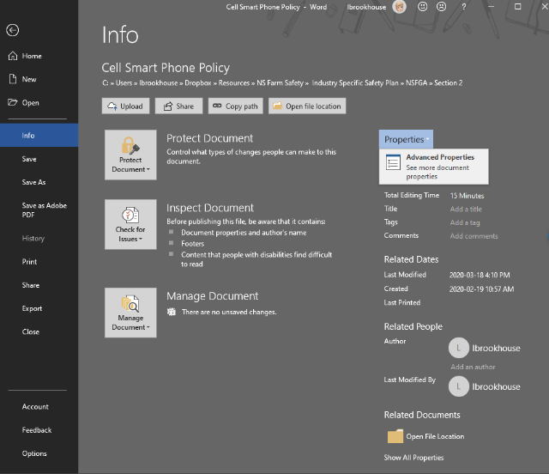
- In the box that opens, at the top are a few tabs, scroll over to the tab that says Custom.
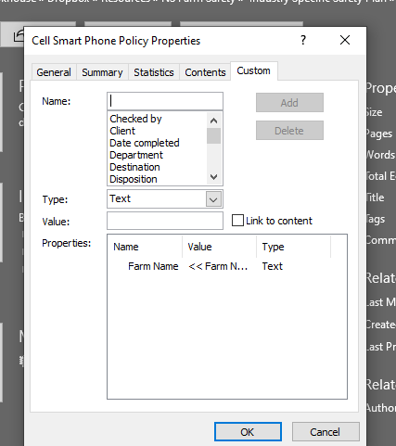
- In the Properties box with Farm Name click Farm Name.
- << FARM NAME >> can now be seen in the Value field.
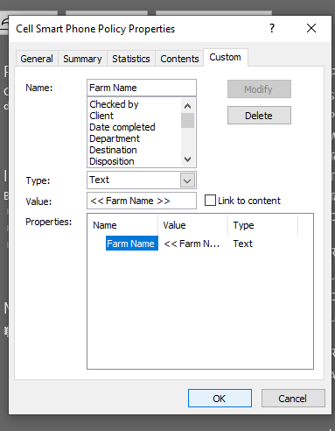
- Delete << FARM NAME >> and type your farm name into this space.
- Then at the top right click Modify.
- Press OK at the bottom of the window.
- Hit the Back Arrow at the top left to go back to your document.
- Highlight the entire document by pressing Control + A at the same time.
- Right click with the mouse and select Update Field.
- 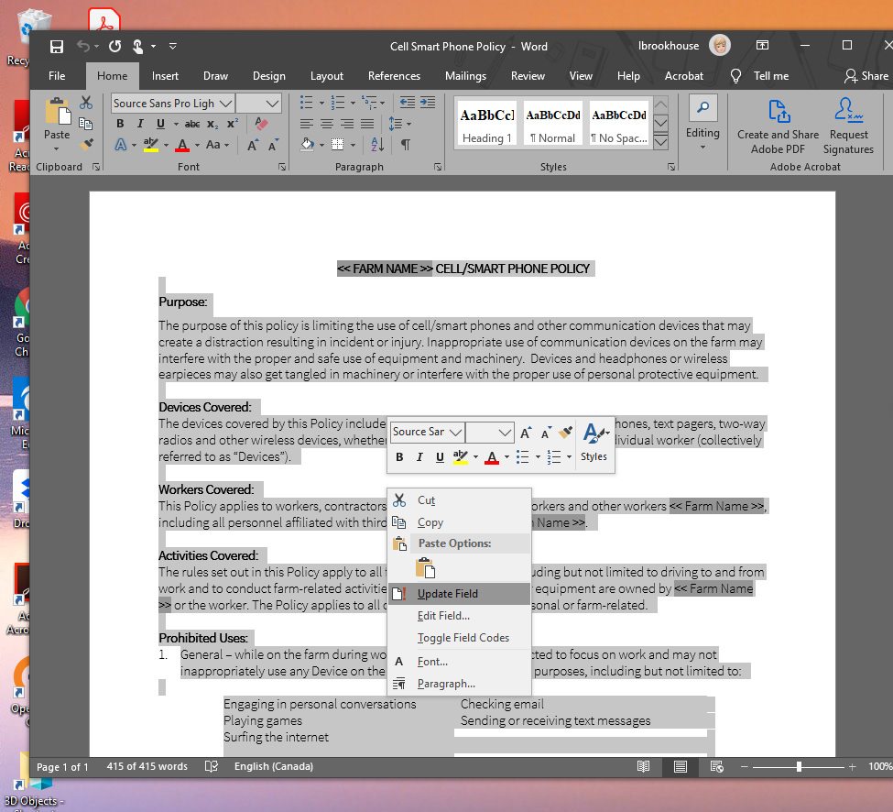
- The form now should have your farm name in every field where << FARM NAME >> was before making the changes.

