Working Alone On Farm
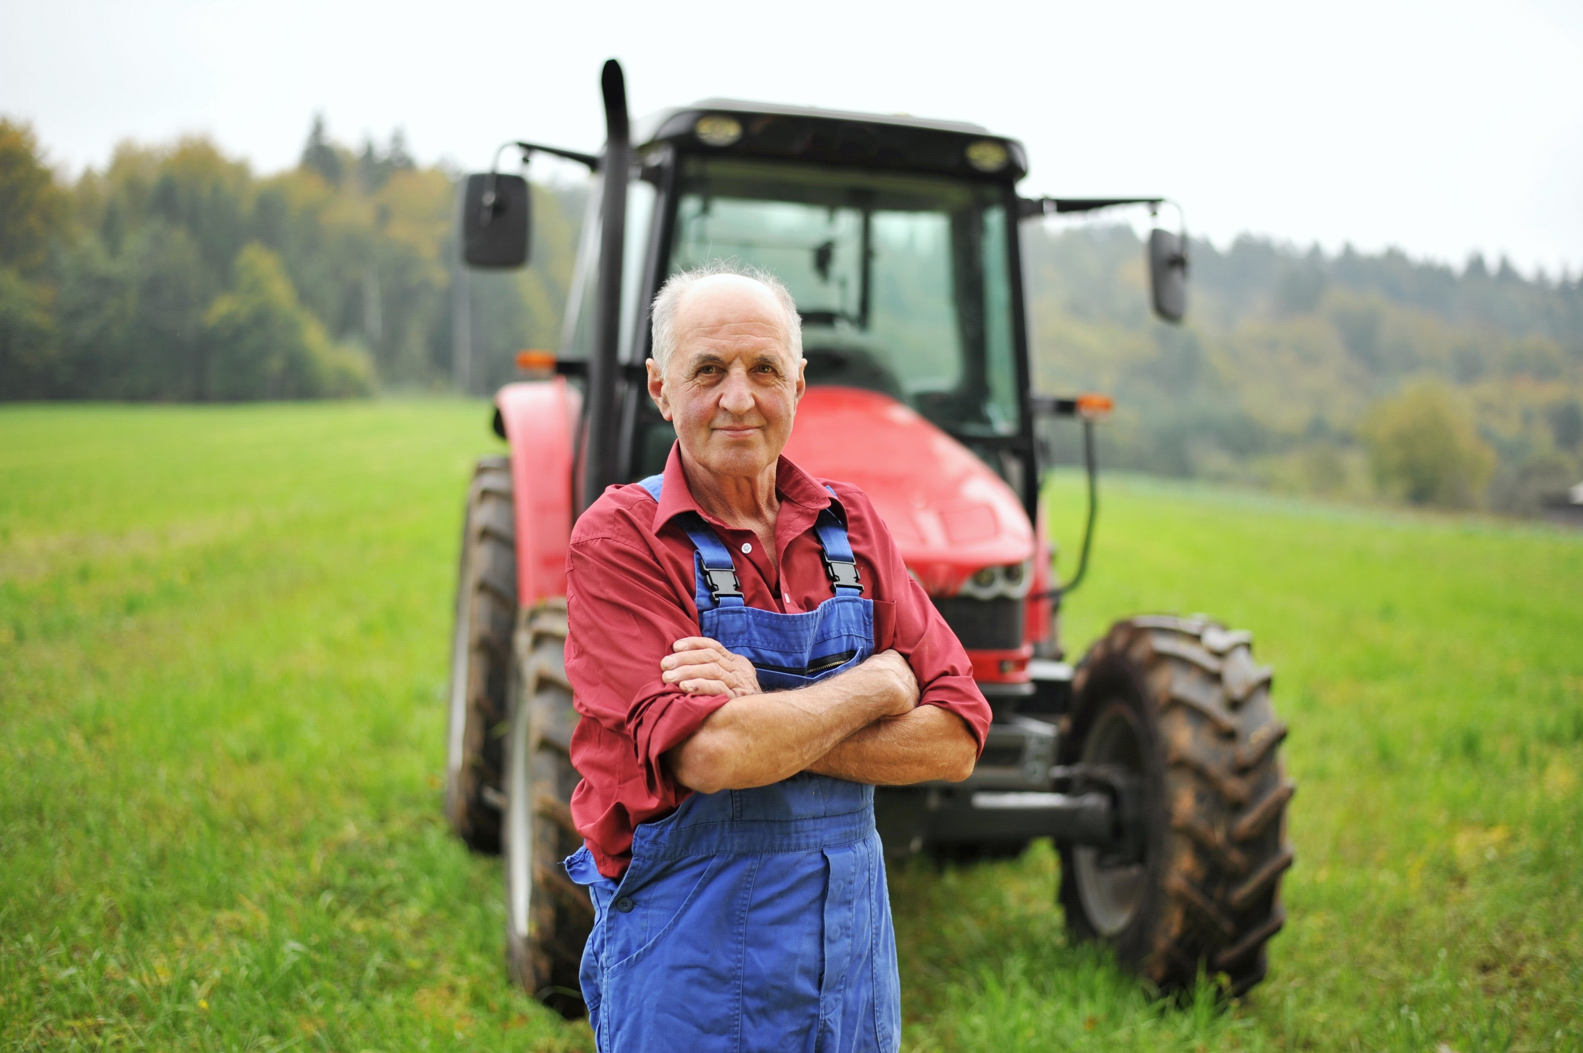
One of the most attractive aspects of farming can be the time away from others to enjoy the great outdoors but dangers lurk when there is no-one to reach out to for help while working in this high hazard industry.

There are many dangers when working on the farm and they vary from commodity to commodity. Some of the common dangers on the farm include tractors and implements or trailers, slips, trips and falls, chemicals, fuels, grain bins, manure pits, long work hours causing fatigue, vibration, electricity, animal handling, stress, climate & weather conditions, medical emergencies, and noise, to just name a few.
These hazards can be very dangerous to work around and when working alone the risk of injury or death increases. If you get hurt and other workers or family don’t know where to find you, this could delay in getting help and you may not be in a position to help yourself if you are unconscious, trapped or seriously injured.

Knowing that working alone may be an unavoidable part of your farming activities, have a plan in place to let people know where you are so if help is needed it can be dispatched more quickly. For example, create a check in system. Have a designated person who could reach you within a reasonable time frame if something was to go wrong. Set a check in schedule for when they expect to hear from you. If they don’t hear from you, they will try to check in with you, and if there is no response, go to your last known location to see if you need help. To reduce the risk, leave high hazard work to when you have help available.
Emergency equipment to have on hand when working alone may include a list of emergency phone numbers, first aid kit, fire extinguisher, eyewash bottle, charger or charging cord for phone or extra battery for two- way radio, extra clothes and/or a change of clothes, set of tools, extra fuel, and a flashlight.
If working with mobile equipment such as tractors or skid steers as well as using implements or attachments read the owner’s manual before operating for the first time and keep handy for any troubleshooting that may arise while performing a task. Only use the implements and attachments for their intended use.

One way to prevent incident or injury while working alone is to ensure all equipment is in good working order. Conduct a pre-trip inspection on mobile equipment and follow maintenance schedules as outlined in manufacturer’s manuals. Ensure competent or professional workers are conducting the maintenance on the equipment. When performing maintenance follow the lockout procedure to de-energize the equipment.
Slips, trips and falls are one of the main causes of injury on the farm. When working alone, be sure to clear equipment steps and handholds of grease, mud, snow and ice before entering and exiting with three points of contact. Ensure foot wear is in good condition and has ample tread or traction for the conditions.
Other tips that can prevent incident and injury while working alone include:
- Conduct a hazard and risk assessment before starting work.
- Have a work plan and follow it.
- Follow safe work practices and written work procedures.
- Don't take short cuts.
- Have an escape plan when working with livestock indoors and outdoors.
- Follow best practices in handling livestock to include avoiding the blind spot.
- Eliminate distractions.
- Wear the correct personal protective equipment for the task performed, tools, equipment or machines used.
- Have a map of all property locations with access points and any particular hazards at those locations such as ponds, wells, manure pits, steep slopes, rivers, ravines, etc. Include emergency response equipment locations as well.
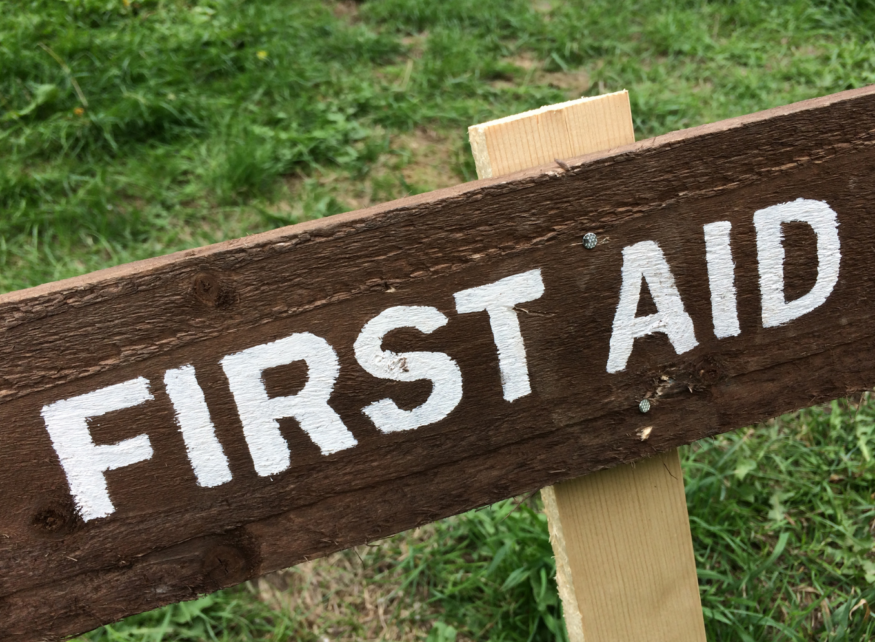
- Be first aid trained; help yourself if there is a medical emergency or if you are injured.
- Have established and practiced emergency response plans in place.
Working Alone On Farm – DISCUSSION RECORD
Agenda:
- Discuss tasks performed alone? What is the risk?
- Is there a check in process in place when working alone?
- What emergency procedures are in place?
- Can working alone be avoided with rescheduling?
Comments or safety concerns as a result of the discussion or observed since the last rally?
______________________________________________________________________________________________________________________________
Follow-up to concerns raised at previous rally?
______________________________________________________________________________________________________________________________
Action Items?
______________________________________________________________________________________________________________________________

Near Miss/Incidents/Unsafe Acts/Conditions to Report?
______________________________________________________________________________________________________________________________

Topics recommended for future Rallies: __________________________________________

Thank the rally members for their participation.
Quiz Answers: 1. T, 2. T, 3. T, 4. e, 5.
TEST YOUR KNOWLEDGE
1. If you get hurt and other workers or family don’t know where to find you, this could delay in getting help and you may not be in a position to help yourself if you are unconscious, trapped or seriously injured. True or False

2. Knowing that working alone may be an unavoidable part of your farming activities, have a plan in place to let people know where you are so if help is needed it can be dispatched more quickly.
True or False
3. One way to prevent incident or injury while working alone is to ensure all equipment is in good working order. True or False
4. Tips when working alone may include:
- Eliminate distractions.
- Don't take short cuts
- Conduct a hazard and risk assessment before starting work.
- Wear the correct personal protective equipment for the task performed, tools, equipment or machines used.
- All of the Above
5. Slips, trips and falls are one of the main causes of injury on the farm.
True or False
Attendance RECORD
*This is to acknowledge that I understand and agree to actively participate in the safety meeting.
Print Name: | Signature:

