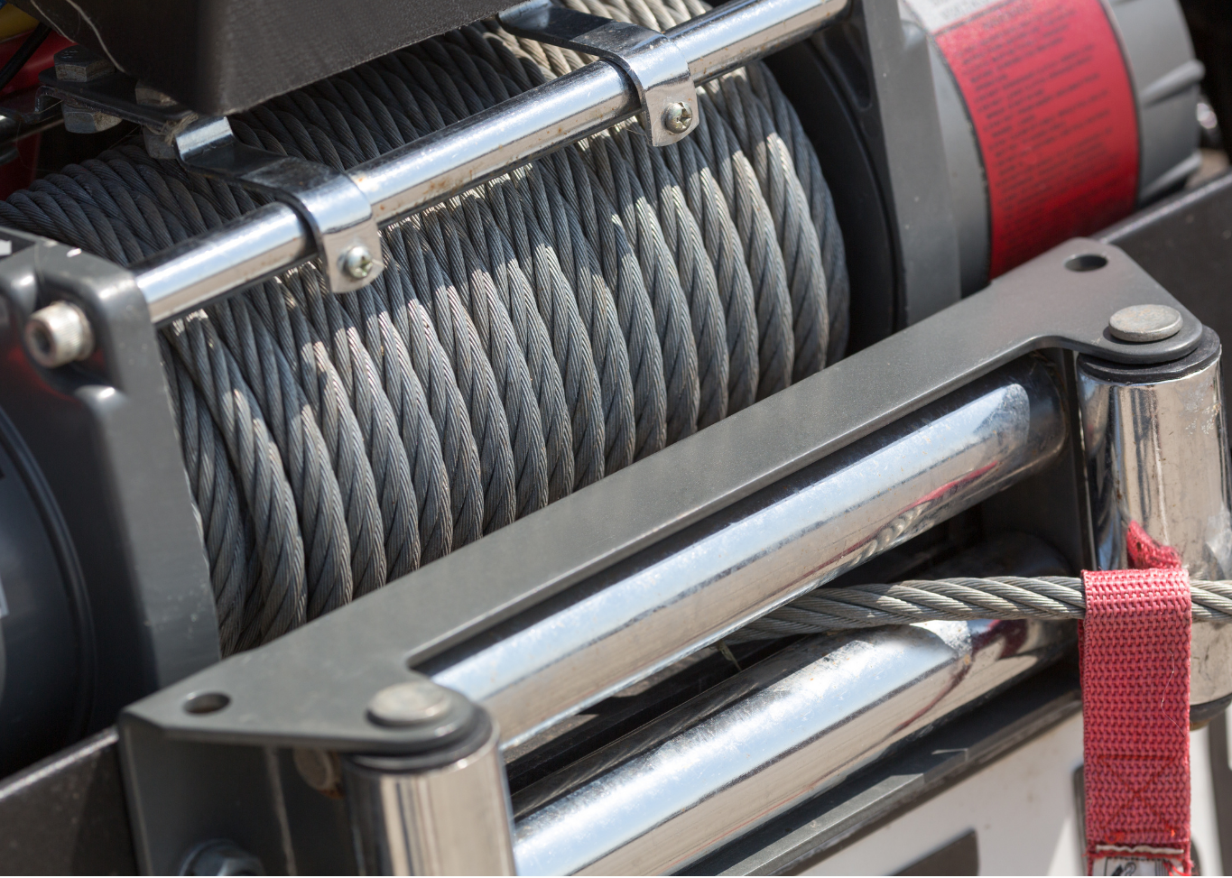
Winch Operation
A winch is a cable that winds around a spool or drum and goes in and out so that it can be attached at one end to an object and tension applied to be able to haul, pull, lift, or position an object.

Read the owner’s manual for the particular winch used on farm to understand the hazards associated with winch operation. Hazards that may be associated with winches include: equipment failure, entanglement, crush injuries, slip & fall, pinch points, amputations, burns and fire.

Once the hazards are identified implement the hierarchy of hazard controls (elimination, engineering, administrative and PPE) to mitigate the hazard and in turn prevent incident and injury while using this handy device.

Communicate with hand signals during operation. Ensure to practice those hand signals with everyone before starting work to ensure each person understands the meaning of the hand signal to avoid hazards associated with mis communication.

Do’s & Don’ts of Winch Operation:
- Choose the winch for the job at hand and the mobile equipment it will be mounted on.
- Know the limitations of the winch. Do not exceed the rated capacity.
- Ensure winch is securely mounted to the mobile equipment as per manufacturers specifications.
  - Competent or professional individuals are to only install and maintain the winch.
- Ensure the winch maintenance is meeting manufacturers schedules.
- Inspect the winch as part of the pre-trip inspection of the mobile equipment and again before use.
  - Check the cable is in good condition & no kinks, cracks, pinches or frays are present.
  - Check accessories for any damage and replace, if damaged.
- Put on PPE before using the winch.
  - Remove Jewelry & no loose clothing and contain long hair and beards.
- Before using the winch for the first time stretch it by winding it around the spool or drum under tension to keep the cable or rope snug.
- Use a strap or similar to avoid hooking back onto the winch line. Hooking back onto the winch line can cause damage or the line to fail.
  - Wind the cable or rope on bottom not overtop of the spool or drum.
- Ensure you have the correct accessory for the job at hand such as straps, shackles snatch block, tree protector, tow hooks, and recovery strap.
- Be trained in correct rigging techniques.
- Close & seat the hook latch in the middle of the hook. Always use a hook with a latch.
- Clear the path of the winch of any obstacles.
- Ensure the mobile equipment can remain stable during the winching operation.
- All ground crew members are to wear high visibility clothing and maintain 10 meters of distance while the winch is operated.
- Do not operate a winch with less than 5 wraps of rope or 10 wraps of synthetic rope on the drum.
- Ensure winch controls are located in a space where they cannot be accidently activated.
- Do not touch the winch rope or accessories while winching is in progress.
- Use slow smooth movements when hauling, pulling, lifting, or positioning an object.
- Use a signaler to direct the movement of material when the operator has a restricted view or hazards exist in the workplace. A signaler must:
  - Be identifiable to the operator.
  - Use well agreed upon hand signals or communication system (two-way radio).
  - Warn operator if the load is in a hazardous position.
  - Ensure they can be seen at all times by the driver. If one signaler cannot be seen by the driver at all times, a second signaler is required.
  - If the signaler(s) are no longer in view, the equipment must stop.
- Do not use the winch to move or hoist people.
- Do not use the winch as a hoist.
- Do not hook cable or rope on electrical lines or exposed moving parts.
- Do not use a winch or operate mobile equipment when impaired.
- Do not submerge winch in water.
Reference: Basic Guide to Winching Techniques by Warn Industries’ Inc.

Winch Operation – DISCUSSION RECORD
Agenda:
- Does the farm use a winch?
- Are workers trained on the use of the winch?
- Are operators’ manuals available?
- Does the farm have a standard set of hand signals?
Comments or safety concerns as a result of the discussion or observed since the last rally?
______________________________________________________________________________________________________________________________
Follow-up to concerns raised at previous rally?
______________________________________________________________________________________________________________________________
Action Items?
______________________________________________________________________________________________________________________________

Near Miss/Incidents/Unsafe Acts/Conditions to Report?
______________________________________________________________________________________________________________________________

Topics recommended for future Rallies: __________________________________________

Thank the rally members for their participation.
Quiz Answers: 1. T, 2. T, 3. e, 4. T
TEST YOUR KNOWLEDGE
1. A winch is a cable that winds around a spool or drum and goes in and out so that it can be attached at one end to an object and tension applied to be able to haul, pull, lift, or position an object.
True or False
2. Read the owner’s manual for the particular winch used on farm to understand the hazards associated with winch operation. True or False
3. Do’s and Don’ts of Winch Operation May include:
- Clear the path of the winch of any obstacles.
- Do not use the winch as a hoist.
- Be trained in correct rigging techniques.
- Know the limitations of the winch. Do not exceed the rated capacity
- All of the Above
4. Communicate with hand signals during operation. Ensure to practice those hand signals with everyone before starting work to ensure each person understands the meaning of the hand signal to avoid hazards associated with mis communication. True or False
Attendance RECORD
*This is to acknowledge that I understand and agree to actively participate in the safety meeting.
Print Name: | Signature:

