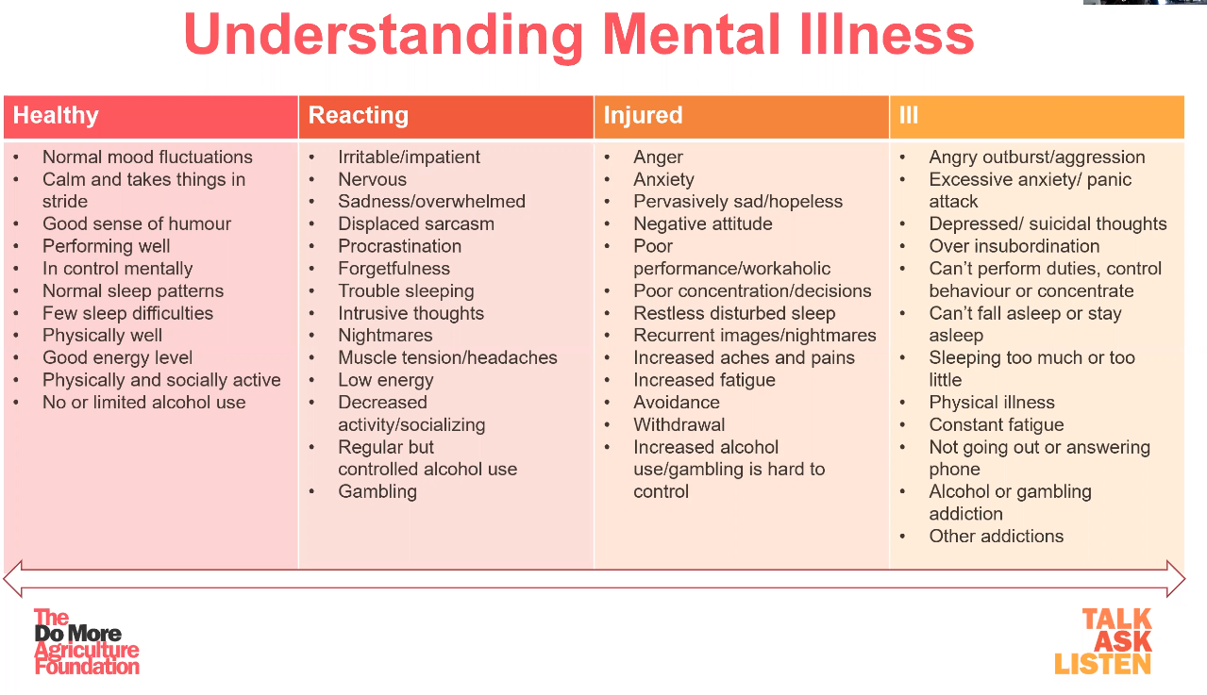
Module 1: Understanding Mental Illness
Stress is not a mental illness but chronic stress can lead to anxiety disorders. Burnout was noted to be persons who are disengaged, whose emotions are blunted, are feeling helpless; lacking motivation, ideals and hope, which all can lead to depression. Mood disorders can include depression, bipolar and suicide disorders.
Mood Disorder Signs & Symptoms may include:

- Changes in appetite or weight
- Sleep problems, increased fatigue & Agitation
- Feelings of worthlessness
- Difficulty concentrating and making decisions
- Recurrent thoughts of suicide
Bipolar Signs & Symptoms may include:
- Extreme Mood swings between depression mania
- Depression
- Mania (Elevated mood, grandiose ideas, rapid speech, lack of insight, increased energy)
Suicide Ideation Signs and Symptoms may include:
- Expressing negative self-comments
- Expressing intent to die by suicide
- Telling final wishes to someone
- Giving away prized possessions
- Loss of interest in friends, hobbies, etc.
- Repeated expressions of hopelessness, helplessness or depression
To assess suicide risk, use the acronym A.G.E.S.
A – Access the risk of suicide or harm;
G – Give reassurance and information;
E – Encourage the person to get professional help;
S - Supports.
Anxiety disorders may include general anxiety, panic attack, obsessive compulsive and PTSD disorders.
Those who experience anxiety may experience physical & psychological signs & symptoms; more is involved than mental reactions but can affect the entire health system.
Experiencing a panic attack may include suffering from more than 4 physical signs and symptoms for more than 10 minutes and may feel intense fear that may be inappropriate to the situation at hand.
Post-Traumatic Stress Disorder (PTSD) signs and symptoms may include reexperiencing the trauma, feeling uneasy, avoidance behaviour, reduced interest in the outside world, persistent increased arousal, jumpy, irritable, outbursts, and insomnia.
Substance related disorder signs and symptoms may include decrease in work habits, sudden mood swings, sudden change in personal habits, sudden change in minor mistakes or accidents, and sudden weight loss. Risk factors that may lead to substance related disorders on the farm include high stress, boredom or repetitive tasks, being isolated/remote area, long work hours, shift work and lack of advancement. Those with substance related disorders may use hallucinogens, depressants and stimulants. Did you know alcohol is a depressant & caffeine and nicotine are stimulants? It is noted that psychological health is a state of well-being in which an individual realizes their own abilities, can cope with the normal stresses of life, can work productively and is able to make a contribution to their community. Final word: “No health without mental health.”

Module 1: Understanding Mental Illness – DISCUSSION RECORD
Agenda:
- Is mental health a discussion that can be held openly on the farm?
- Discuss the supports & Resources available?
- Review the We Talk. We Grow web page.
Comments or safety concerns as a result of the discussion or observed since the last rally?
______________________________________________________________________________________________________________________________
Follow-up to concerns raised at previous rally?
______________________________________________________________________________________________________________________________
Action Items?
______________________________________________________________________________________________________________________________

Near Miss/Incidents/Unsafe Acts/Conditions to Report?
______________________________________________________________________________________________________________________________

Topics recommended for future Rallies: __________________________________________

Thank the rally members for their participation.
Quiz Answers: 1. T, 2. T, 3. e, 4. T, 5. T
TEST YOUR KNOWLEDGE
1. Burnout was noted to be persons who are disengaged, whose emotions are blunted, are feeling helpless, lacking motivation, ideals and hope which, all can lead to depression.
True or False
2. Those who experience anxiety may experience physical & psychological signs & symptoms; more is involved than mental reactions but can affect the entire health system. True or False
3. Mood disorder signs and symptoms may include:
- Changes in appetite or weight
- Sleep problems, increased fatigue & Agitation
- Feelings of worthlessness
- Difficulty concentrating and making decisions
- All of the Above
4. Substance related disorder signs and symptoms may include decrease in work habits, sudden mood swings, sudden change in personal habits, sudden change in minor mistakes or accidents, and sudden weight loss. True or False

5. “No health without mental health.” True or False
Attendance RECORD
*This is to acknowledge that I understand and agree to actively participate in the safety meeting.
Print Name: | Signature:

