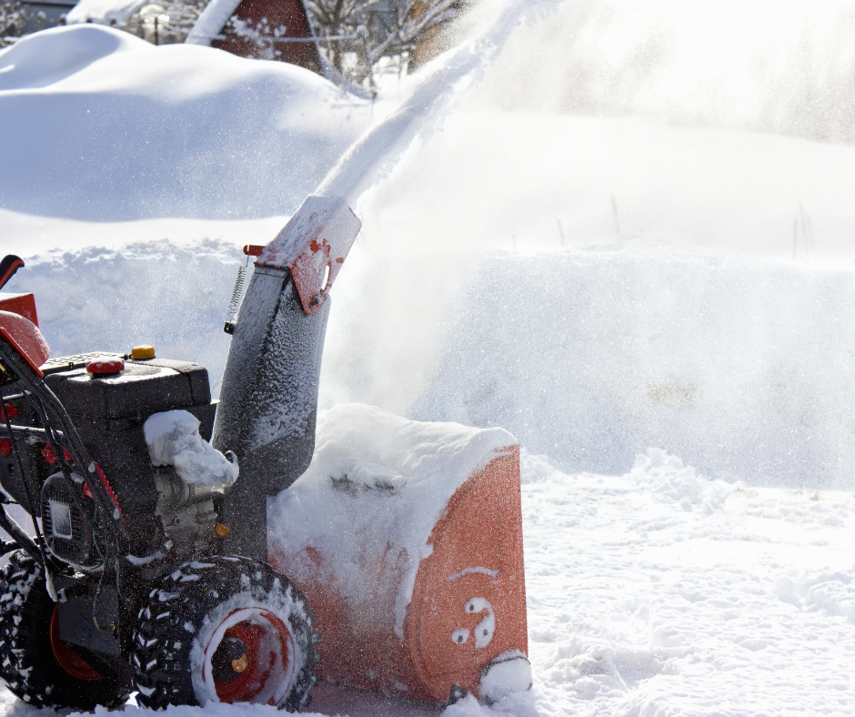
Snow Blower Safety
Snow blowers are great machines to move snow from farm lanes, driveways, and paths to the barns, by reducing the manual labour of shoveling. As with most machines, there still are risks. For example, the machine has moving parts as well as it can throw rocks and other material hidden in the snow. Each year users suffer from injuries while using snow blowers such as amputations, eye injuries, burns, and strains and sprains.

Amputations occur when the operator tries to unclog the chute using their hands or feet. Even though the machine is turned off, the blades can still rotate, subsequently cutting the persons fingers, hands or feet while trying to move clogs.

Operators and bystanders can suffer eye injuries from objects thrown from the machine and burns when exposed to the hot muffler.

Strains and sprains can occur when the machine is manually operated through slips and trips from loose snow or ice under the snow. Strains and sprains also occur when the operator gets in and out of the tractor without cleaning the snow off their boots.

Other dangers associated with using snow blowers are PTO, electrical shock, fumes/exhaust, leaking gases or spills, fuelling a hot machine, and tire overinflation. To prevent these types of injuries, consider the following tips:
- When performing maintenance:
  - Read the manufacturer’s manual before use and when performing maintenance.
  - Conduct a pre-use inspection.
  - Keep the snow blower in good repair by following the maintenance schedules outlined in the manufacturer’s manual.
  - Ensure the equipment is grounded.
  - Disconnect it from the power source.
  - Ensure guards are in place.
  - Do not overinflate tires, follow the PSI rating on the tire.
  - Ensure the machine is turned off before removing clogs.
  - Do not use hands or feet to remove jams or clogs.
  - Refuel the machine before use, and don’t add fuel when the engine is hot.
- Conduct a hazard assessment and remove any obstacles and debris from the work area before operating the snow blower.
- Do not affix or disable the emergency stop lever to allow the machine to continue to run.
  - Disengage the PTO before exiting the tractor.
- Point the chute away from people, objects and public roads.
- Do not blow snow out into roads, buildup of the snow may cause a vehicle to lose control.
- Keep pets, farm animals, and children indoors.
- Keep clothing & hair away from the auger at the front of the snowblower, including scarfs, hoods, hood strings, snow pants, long hair, boot laces. They can become entangled in the auger.
- If using a PTO driving snow blower, keep clothing and hair from the PTO shaft.
- Run the snowblower outside only.
- Wear the PPE recommended by the manufacturer to include boots with good grip and perhaps the use of ice cleats for icy conditions.
  - Do not wear cleats if entering a tractor or other machinery to which the snowblower is attached.
  - Wear safety glasses with tint to reduce glare from the snow during the day, and wear safety glasses which brighten the environment when working at night.
- In addition to personal protective equipment, wear layers of warm clothing that wick away sweat, hat without strings, and gloves with grip for the handles or steering wheel.
- Prevent clogs by:
  - Work quickly to prevent snow from sticking.
  - If the snow is heavy and wet, snow blow several times throughout the event instead of waiting until after the snow fall.
  - Spray auger blades with lubricant, if approved by the manufacturer.
- Remove clogs by:
  - Turning off the PTO or machine.
  - Disengage the clutch.
  - Wait for the blades to stop moving.
  - Keep all guards in place.
  - Use an object like a stick or pole rather than hands and feet to work around.

Snow Blower Safety – DISCUSSION RECORD
Agenda:
- Does the farm use snowblowers to remove snow?
- Are workers trained on the use of the machine?
- Are operators’ manuals available for PTO and manual operated snow blowers?
Comments or safety concerns as a result of the discussion or observed since the last rally?
______________________________________________________________________________________________________________________________
Follow-up to concerns raised at previous rally?
______________________________________________________________________________________________________________________________
Action Items?
______________________________________________________________________________________________________________________________

Near Miss/Incidents/Unsafe Acts/Conditions to Report?
______________________________________________________________________________________________________________________________

Topics recommended for future Rallies: __________________________________________

Thank the rally members for their participation.
Quiz Answers: 1. T, 2. T, 3. e, 4. a, 5. T
TEST YOUR KNOWLEDGE
1. Amputations occur when the operator tries to unclog the chute using their hands or feet. Even though the machine is turned off, the blades can still rotate, subsequently cutting the persons fingers, hands or feet while trying to move clogs.
True or False
2. Operators and bystanders can suffer eye injuries from objects thrown from the machine and burns when exposed to the hot muffler. True or False
3. Remove clogs by:
- Turning off the PTO or machine
- Disengage the clutch.
- Wait for the blades to stop moving.
- Use an object like a stick or pole rather than hands and feet to work around
- All of the Above
4. Wear the PPE recommended by the _____________ to include boots with good grip and perhaps the use of ice cleats for icy conditions
- Manufacturer
- Farm Owner
- Neighbour
5. Conduct a pre-use inspection before operating the snowblower each day. True or False
Attendance RECORD
*This is to acknowledge that I understand and agree to actively participate in the safety meeting.
Print Name: | Signature:

