Module 2: Recognizing & Providing Support
It is important to evaluate the “Rule Out Rule” meaning to explore the possibility that the changes in behaviour may be unrelated to a mental health issue before taking action. To help do this, you can engage with the person and say you have noticed changes and try to engage them in a conversation to determine if there is an issue. During the engagement, be sure to stick to the facts, prepare yourself in allowing enough time for a conversation whether long or short, be prepared for a reaction, (the person may not be prepared to talk and dismiss you), listen with intent to understand and have resources on hand to share with the person.
The support through stages of personal change were shared below: 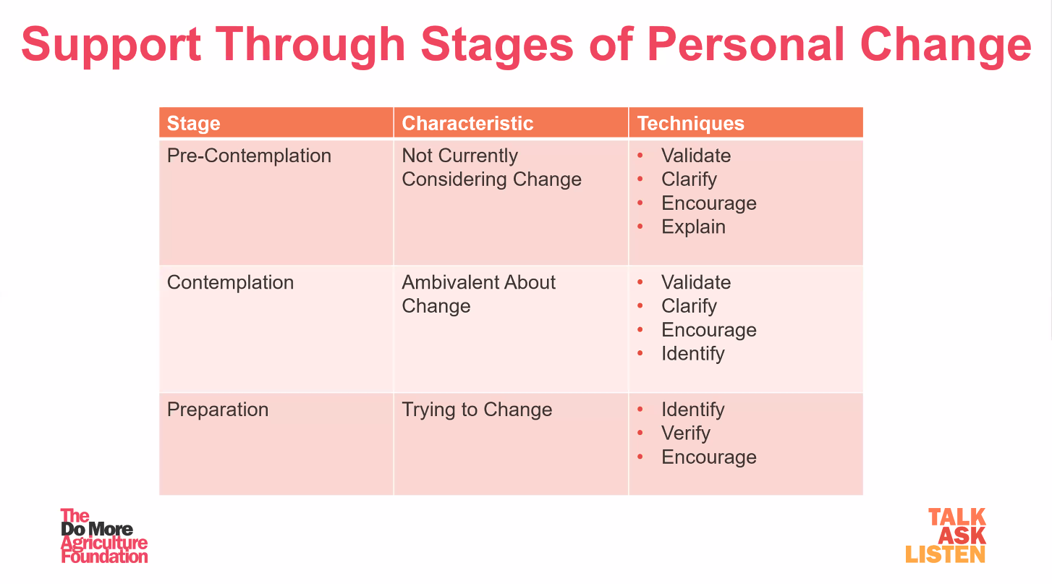

Listening with intent is to also listen with empathy rather than sympathy which was demonstrated well through this video from Dr. Brene Brown, called “The Power of Empathy.”
Follow up and checking in is key in showing support to those who may need it at this point in time in their life.
The Farm Family Support Center is a member assistance program by Morneau Shepell. Farmers and their families have access to up to 3 hours of service at no cost. The service is supported by Farm Safety Nova Scotia and is confidential. Your information is not shared with the NSFA or FSNS. Call 1.844.880.9142 for confidential and immediate support 24/7/365.
Solutions for a wide range of life’s challenges.

Achieve well-being
- Stress
- Depression
- Anxiety
- Anger
- Crisis situations
- Life transitions
Manage relationships and family
- Separation and divorce
- Elder care
- Relationship conflict
- Parenting
- Blended Family issues
Tackle addictions
- Alcohol
- Tobacco
- Drugs
- Gambling
- Other addictions
- Post-recovery support
Get legal advice
- Separation and divorce
- Civil litigation
- Custody and child support
- Wills and estate planning

Module 2: Recognizing & Providing Support – DISCUSSION RECORD
Agenda:
- Are you aware of the supports available for mental health & wellness?
- Discuss the supports & resources available?
- Review the We Talk. We Grow. web page.
Comments or safety concerns as a result of the discussion or observed since the last rally?
______________________________________________________________________________________________________________________________
Follow-up to concerns raised at previous rally?
______________________________________________________________________________________________________________________________
Action Items?
______________________________________________________________________________________________________________________________

Near Miss/Incidents/Unsafe Acts/Conditions to Report?
______________________________________________________________________________________________________________________________

Topics recommended for future Rallies: __________________________________________

Thank the rally members for their participation.
Quiz Answers: 1. T, 2. T, 3. e, 4. T, 5. T
TEST YOUR KNOWLEDGE
1. You can engage with the person and say you have noticed changes and try to engage them in a conversation to determine if there is an issue.
True or False

2. Three stages of support include pre-contemplation, contemplation, and preparation. True or False
3. When offering support:
- Stick to the facts
- Allow plenty of time to engage
- Prepare for a reaction
- Listen intently
- All of the Above
4. The Farm Family Support Center is a member assistance program by Morneau Shepell. Farmers and their families have access to up to 3 hours of service at no cost. True or False

5. Listen with empathy rather than sympathy.
True or False
Attendance RECORD
*This is to acknowledge that I understand and agree to actively participate in the safety meeting.
Print Name: | Signature:

