THE IN’S AND OUT’S OF POWER TAKE OFF (PTO)
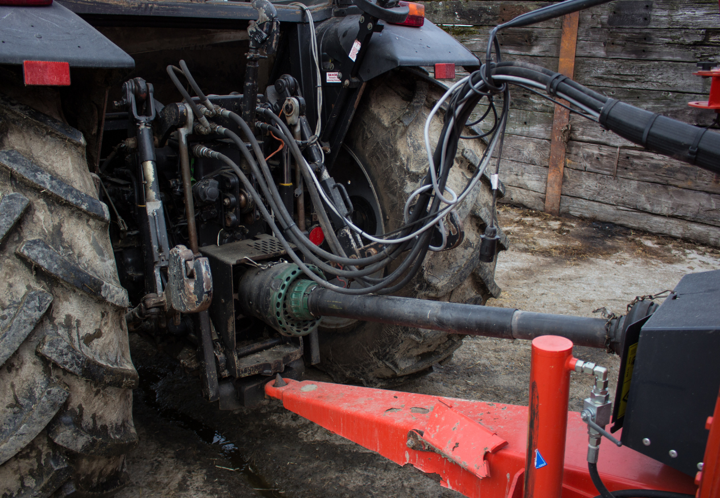
Power Take Off is a driveline with a powerful means to transfer energy to operate farm equipment such as generators, augers, silage blowers, mowers, grain mixers, forage wagons, balers, manure spreaders, and many more.
The PTO driveline goes from the tractor and connects to the implement. PTO’s can operate at 540 rpm or 1000 rpm. The driveline rotates at approximately 9 times per second when set at a speed of 540 rpm. The driveline rotates at almost 17 times per second when set at a speed of 100 rpm. At both speeds there is no time for a worker to react if a rag they are holding, a shoelace, a hoody string, or even a string hanging off a pair of jeans becomes entangled.

When the rag, shoelace or string is caught on the driveline, the tension on the piece from the driveline pulls the worker into and then around the drive shaft. When a worker is caught in the driveline, they try to pull themselves free but this action only causes them to be more tightly pulled in.

One fellow was lucky when he only lost the tip of his middle finger when the rag he was wiping his hands with got caught by the PTO shaft while he was standing over his repair work.
To prevent worker incident or injury while working around PTO, consider these hints and tips:
- Following the safe work practice for hitching & unhitching.
- Ensure the correct drive line is used and the drawbar is aligned correctly for each implement.
- Ensure PTO driveline is locked into position.
- Ensure guards are in place while PTO is operating and replace guards immediately after performing maintenance.
- Inspection the PTO assembly as per the manufacturers specifications to identify any damage or defects before an incident can happen.
- Perform cleaning, maintenance and service as per schedules outlined in the manufacturer’s manuals.
- Refer to the manufacturers manual before purchasing replacement parts. Only use replacement parts recommended by the manufacturer.
- Never step over a drive shaft that is operating or rotating.
- Disengage PTO before leaving the tractor.
- Do not perform maintenance on the tractor or implement with the PTO engaged.
- Do not wear loose fitting clothing such as bagging clothes, loose hoodie strings, untied shoelaces, and ripped or torn pants with strings around PTO.
- Contain long hair and beards when working around PTO.
- Check that warning signs are posted and legible on the equipment.

THE IN’S AND OUT’S OF POWER TAKE OFF (PTO) – DISCUSSION RECORD
Agenda:
- Evaluate the equipment and machinery on farm that use PTO?
- Are the guards in place for the equipment and machinery identified?
- Is training provided on PTO?
- Are hazard warning signs/decals/labels visible?
Comments or safety concerns as a result of the discussion or observed since the last rally?
______________________________________________________________________________________________________________________________
Follow-up to concerns raised at previous rally?
______________________________________________________________________________________________________________________________
Action Items?
______________________________________________________________________________________________________________________________

Near Miss/Incidents/Unsafe Acts/Conditions to Report?
______________________________________________________________________________________________________________________________

Topics recommended for future Rallies: __________________________________________

Thank the rally members for their participation.
Quiz Answers: 1. T, 2. T, 3. T, 4. e, 5.
TEST YOUR KNOWLEDGE
1. Power Take Off is a driveline with a powerful means to transfer energy to operate farm equipment such as generators, augers, and mowers. True or False

2. PTO’s can operate at 540 rpm or 1000 rpm.
True or False
3. There is no time for a worker to react if a rag they are holding, a shoelace, a hoody string, or even a string hanging off a pair of jeans becomes entangled. True or False
4. Prevention methods from entanglement may include:
- Ensure PTO driveline is locked into position
- Ensure guards are in place
- Never step over a drive shaft that is operating
- Do not perform maintenance on the tractor or implement with the PTO engaged.
- All of the Above
5. Do not wear loose fitting clothing such as bagging clothes, loose hoodie strings, untied shoelaces, and ripped or torn pants with strings around PTO.
True or False
Attendance RECORD
*This is to acknowledge that I understand and agree to actively participate in the safety meeting.
Print Name: | Signature:

