Causes of Back Injuries

Back injuries are one of the most common types of injuries when working on the farm.
Causes of back injuries include:

- Handling Livestock
- Prolonged Sitting
- Repetitive Motion
- Forceful Movement
- Awkward Positions
- Lifting
- Long Hours
- Whole Body Vibration
- Slips, Trips & Falls
- Physical Condition
- Reaching or Lifting Overhead

Symptoms may vary from person to person from mild to severe in which it inhibits normal body function.
Symptoms of Back Injuries:

- Stiffness
- Sciatica Type Pain down the legs
- Pain
- Numbness in feet & toes
- Inability to Move
- Difficulty walking or sitting

Types of back injuries include:
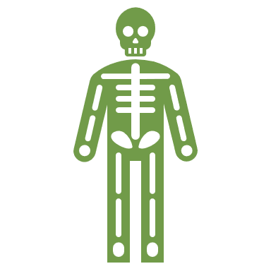
- Sprains/Strains caused by falling, twisting, and impact
  - Sprains occur when ligament (join tissue to bone) are torn or stretched.
  - Strains occur when muscles or tendons (join muscle to bone) become stretched or torn.
- Herniated Disks which bulge or rupture or break down with age.
  - Reduces cushioning between the bones.
  - Irritates nerves in the surrounding area.
  - Cause pain, numbness, and tingling in the back or running down the leg.
- Fractured Vertebrae along cervical, thoracic or lumbar spine
  - Caused by falls, impact to the spine or compression of the back.
Manage Chronic pain:
- Massage, heat, Epsom salt baths to relieve muscle tension.
- Any treatment is comprehensive and targets physical, emotional and cognitive needs.
- See medical treatment when needed.
- Deep breathing or other stress management techniques.
- Pace yourself while working.
- Maintain a positive attitude.
- Incorporate rest, exercise and relaxation into daily schedule.
- Decrease or eliminate alcohol consumption.
- Know your medication.
- Quite smoking.
Protect yourself by taking measures early to prevent back problems in the future.

Causes of Back Injuries – DISCUSSION RECORD
Agenda:
- What activities commonly performed on the farm cause back injuries?
- What hazard control methods are in place to prevent back injuries?
Comments or safety concerns as a result of the discussion or observed since the last rally?
______________________________________________________________________________________________________________________________
Follow-up to concerns raised at previous rally?
______________________________________________________________________________________________________________________________
Action Items?
______________________________________________________________________________________________________________________________

Near Miss/Incidents/Unsafe Acts/Conditions to Report?
______________________________________________________________________________________________________________________________

Topics recommended for future Rallies: __________________________________________

Thank the rally members for their participation.
Quiz Answers: 1. T, 2. T, 3. d, 4. T, 5. T
TEST YOUR KNOWLEDGE
1. Symptoms of back pain may vary from person to person from mild to severe in which it inhibits normal body function.
True or False
2. Back injuries are one of the most common types of injuries when working on the farm such as when handling livestock, lifting, and working long hours. True or False
3. Type of back injuries include:
- Strains/Sprains
- Herniated disks
- Fractured vertebrae
- All of the Above
4. There are various methods in managing chronic pain to include massage and physio therapy, breathing and stress management techniques, and maintaining a positive attitude. True or False
5. Protect yourself by taking measures early to prevent back problems in the future True or False
Attendance RECORD
*This is to acknowledge that I understand and agree to actively participate in the safety meeting.
Print Name: | Signature:

