WHMIS 2015

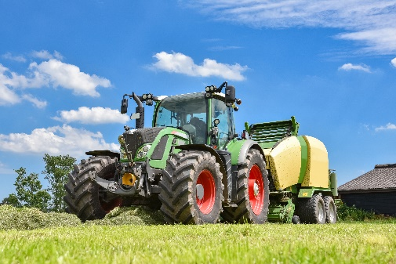
Chemicals are a health hazard and are covered under a National program called the Global Harmonized System. WHMIS 2015 is part of the Global Harmonized System which is a process for classifying and labeling chemicals or hazardous products.
WHMIS 2015 is a training program involving the classification and labelling of chemicals or hazardous products. The training system involves worker education where the worker learns how to read supplier labels, create workplace labels, and read Safety Data Sheets (SDS) in order to protect themselves against the hazards of chemicals or hazardous products.
The Farm Sustainability Assessment Tool (http://fsatool.com/) code FSA105 asks, “Do you ensure that workers who handle hazardous materials are not younger than 18 or pregnant and do not suffer from chronic or respiratory disease?” So, if you are using chemicals or hazardous products on your farm, and workers are working with the chemicals or hazardous products or in the proximity of chemicals or hazardous products, then those workers should be trained in WHMIS 2015. Those who are under 18, pregnant and have a respiratory disease should not be working with chemicals or hazardous products.
It is best to provide training on WHMIS 2015 before farmers and workers use or work around chemicals or hazardous products such as on the first day of work, a worker assigned to a new position, or using chemicals or hazardous products for the first time.
WHMIS 2015 training includes information found on a Safety Data Sheet (SDS), location of the SDS on the farm, information on supplier and workplace labels, procedures for the safe storage, handling, use, and disposal of hazardous products or chemicals as well as procedures for emergency response or exposure to the hazardous product or chemical.
Farm Safety Nova Scotia offers online agriculture specific training course in WHMIS 2015. Check out the course to provide your workers training before they work with or around chemicals on farm.
Once training is conducted, farmers, check that workers understand the training and can apply the training in the workplace. Workers can be given written or oral tests or checklists, or can do a demonstration to show you what they have learned in training.
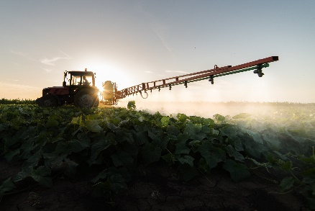
Conduct refresher training when conditions in the workplace change, chemicals or hazardous products have changed, evaluations indicate that training is inadequate, or that previous training is no longer effective.
WHMIS training improves hazard communication which will in turn improve on-farm sustainability.
Ensure to post resources for workers to reference as a continuous reminder on how to prevent incident and injury while using chemicals. Post a reference sheet on the different pictograms that can be found on labels and in safety data sheets. Ensure safety data sheets are available with the chemical being used. Place blank workplace labels in areas where there are decant containers so workers can easily correctly label the them.

WHMIS 2015 – DISCUSSION RECORD

Agenda:
- Do workers working with and around chemicals have the required training – check the training matrix.
- Are safety data sheets placed with chemicals used?
- Are safety data sheets up to date?
- Are workers applying their WHMIS knowledge?
- Are labels readable and is the correct label applied?
Comments or safety concerns as a result of the discussion or observed since the last rally?
______________________________________________________________________________________________________________________________
Follow-up to concerns raised at previous rally?
______________________________________________________________________________________________________________________________
Action Items?
______________________________________________________________________________________________________________________________

Near Miss/Incidents/Unsafe Acts/Conditions to Report?
______________________________________________________________________________________________________________________________
Topics recommended for future Rallies: __________________________________________

Thank the rally members for their participation.
Quiz Answers: 1. T, 2. T, 3. d, 4. d, 5. T
TEST YOUR KNOWLEDGE
1. WHMIS stands for Workplace Hazardous Materials Information System. True or False
2. WHMIS 2015 is a training program involving the classification and labelling of chemicals or hazardous products. True or False
3. WHMIS 2015 training includes:
- Reading Labels
- Creating Workplace Labels
- Reading Safety Data Sheets (SDS)
- All of the Above
4. Workers are required to apply WHMIS training in the workplace to include:
- Knowing location of Safety Data Sheets (SDS)
- Safe storage, handling, use, and disposal of hazardous products.
- Procedures for emergency response or exposure to the hazardous product or chemical.
- All of the above
5. Provide training on WHMIS 2015 before farmers and workers use or work around chemicals or hazardous products such as on the first day of work, a worker assigned to a new position, or using chemicals or hazardous products for the first time. True or False
Attendance RECORD
*This is to acknowledge that I understand and agree to actively participate in the safety meeting.
Print Name: | Signature:

