Protect Your Eyes from the Sun!
When preparing to work outdoors on the farm we consider the clothing to be worn and how to protect our skin through the use of sunscreen. We often forget that we need to protect our eyes from the sun as well. We know sunglasses can help with this but did you know that prescription eyewear should have UV light protection too? If you do not protect your eyes against UV rays, lens and retina damage can harm your vision.
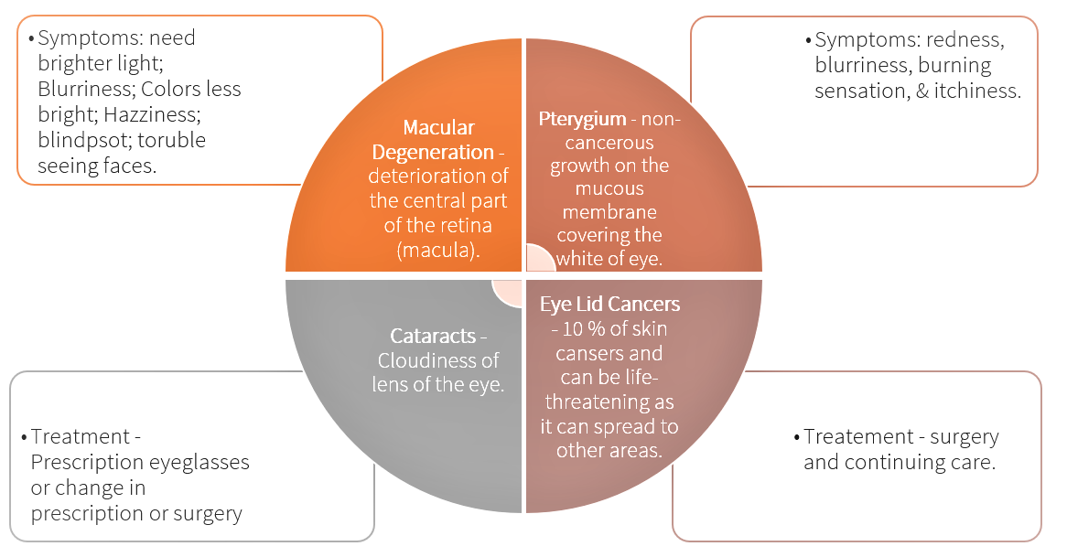

Reflected light from water, sand, pavement, snow and reflective building structures & equipment can cause eye burn. Keep in mind that UV rays are not blocked by clouds. Protect your eyes against UV ray exposure even on cloudy days.
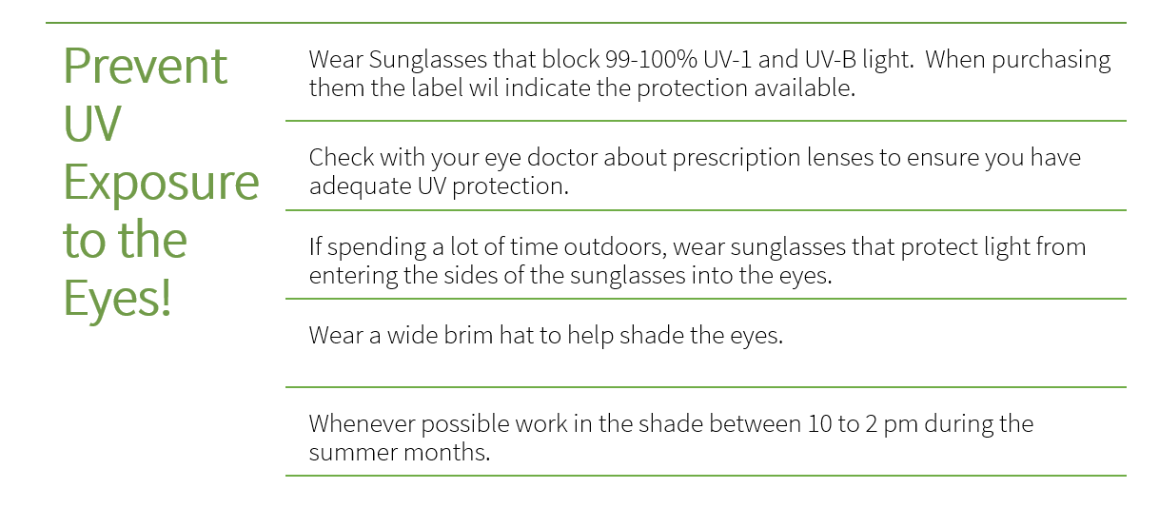

Protect Your Eyes from the Sun! – DISCUSSION RECORD
Agenda:
- Discuss what tasks on the farm require eye protection?
- Does eye protection available also protect against UV protection?
- Do workers who wear glasses have a means to protect their eyes against UV from the Sun?
Comments or safety concerns as a result of the discussion or observed since the last rally?
______________________________________________________________________________________________________________________________
Follow-up to concerns raised at previous rally?
______________________________________________________________________________________________________________________________
Action Items?
______________________________________________________________________________________________________________________________

Near Miss/Incidents/Unsafe Acts/Conditions to Report?
______________________________________________________________________________________________________________________________

Topics recommended for future Rallies: __________________________________________

Thank the rally members for their participation.
Quiz Answers: 1. T, 2. T, 3. d, 4.d
TEST YOUR KNOWLEDGE
1. If you do not protect your eyes against UV rays, lens and retina damage can harm your vision. True or False
2. Reflected light from water, sand, pavement, snow and reflective building structures & equipment can cause eye burn.
True or False
3. Which of the following are symptoms of macular degeneration?
- Need brighter light
- Blurriness
- Colors don’t seem as bright
- All of the Above
4. Which of the following are methods of to protect your eyes against UV exposure?
- Wear Sunglasses that block 99-100% UV-1 and UV-B light
- Wear a wide brim hat to help shade the eyes.
- Check with your eye doctor about prescription lenses to ensure adequate UV protection.
- All of the above.
Attendance RECORD
*This is to acknowledge that I understand and agree to actively participate in the safety meeting.
Print Name: | Signature:

