How to Access NFPA Codes Referenced in OHS Legislation!
Compliance with National Fire Protection codes (NFPA) and standards is voluntary. However, if the Nova Scotia Occupational Safety and Health Act & Regulations make reference to them, then complying with the codes and standards is mandatory. For example, the Nova Scotia Occupational Health and Safety General Regulations references the fire protection codes in Part 4: Ventilation, Lighting, Sanitation and Accommodation, Section 25: Fire Protection & Escape.
Almost every building, process, service, design, and installation is affected by NFPA’s more than 275 codes and standards. The codes and standards, are available online for free. They reflect changing industry needs and evolving technologies, supported by research and development, and practical experience. They are designed to minimize the risk and effects of fire by establishing criteria for building, processing, design, service, and installation around the world.
One of the National Fire Protection Codes you may be familiar with is NFPA 10. This is a National Fire Protection Code for portable fire extinguishers which is one of the basic firefighting requirements for buildings and equipment.
To view the codes, go the National Fire Protection Association website.
To view Codes and Standards for free click on “Codes & Standards” in the red bar toward the top of the page.
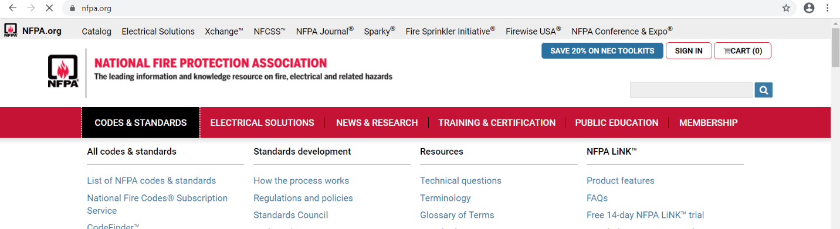
Then click “List of Codes & Standards” in blue print when the new window opens up.
A list of all available NFPA codes will show up in a list. The list is organized by NFPA number starting at 1 and going all the way to NFPA 8506. We are going to take a look at NFPA 10 Portable Fire Extinguishers. Click on the blue text for NFPA 10.
To view the document, click “Free Access” which is to the right of “Subscribe to Access Now” button. Then scroll to “Select the Free Access Edition” below and then click “View.” In the new window, “Create a Profile” to view NFPA Code 10. It is to the right of the “Sign In” button in very small blue print.
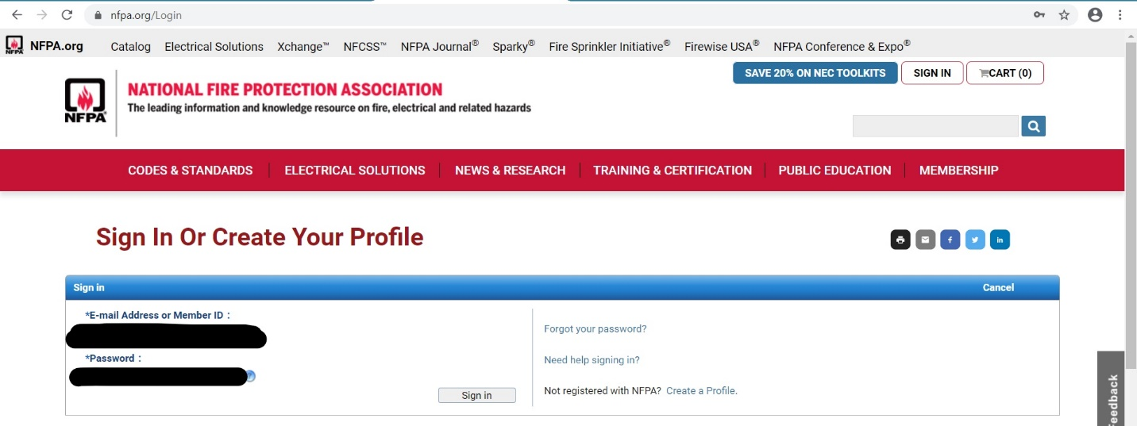
Once your profile is created, the standard will be ready to view. Navigate the standard by using the buttons at the bottom of the document. After creating a profile, keep the username and password in a safe place as you will use this information to view other NFPA codes, perhaps at another time.

How to Access NFPA Codes Referenced in OHS Legislation! – DISCUSSION RECORD
Agenda:
- Discuss applicable NFPA codes for farm tasks as well as what may be valuable to implement at home in regards to fire safety.
- Demonstrate how to access the standards NFPA codes.
Comments or safety concerns as a result of the discussion or observed since the last rally?
______________________________________________________________________________________________________________________________
Follow-up to concerns raised at previous rally?
______________________________________________________________________________________________________________________________
Action Items?
______________________________________________________________________________________________________________________________

Near Miss/Incidents/Unsafe Acts/Conditions to Report?
______________________________________________________________________________________________________________________________

Topics recommended for future Rallies: __________________________________________

Thank the rally members for their participation.
Quiz Answers: 1. T, 2. T, 3. a, 4. b,
TEST YOUR KNOWLEDGE
1. If the Nova Scotia Occupational Safety and Health Act & Regulations make reference to NFPA Code, then complying with the codes and standards is mandatory. True or False
2. NFPA Codes are designed to minimize the risk and effects of fire by establishing criteria for building, processing, design, service, and installation around the world. True or False
3. The National Fire Protection Code for Portable fire Extinguishers is:
- 10
- 30
- 101
- 70E
- All of the Above
4. Almost every building, process, service, design, and installation is affected by NFPA’s more than _______ codes and standards.
- 775
- 275
- 375
Attendance RECORD
*This is to acknowledge that I understand and agree to actively participate in the safety meeting.
Print Name: | Signature:

