Mind the G.A.P. FARM FARM FARM

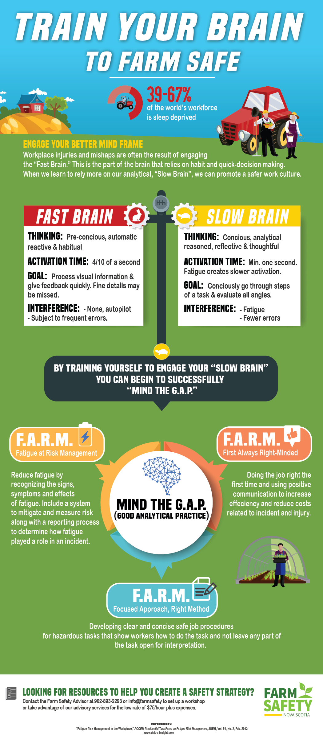
According to Dekra (www.dekra-insight.com), you need to use the slow part of your brain designed for conscious, analytical, reasoned, reflective and thoughtful thinking. Not as easy as it sounds, as this part of the brain takes at least one second to activate.
Meanwhile the part of the brain that is in charge of pre-conscious, automatic, reactive and habitual thinking only takes about 4/10 of a second to activate and uses less energy. The goal of fast brain is to process visual information and deliver feedback as quickly as possible resulting in generalized visual perceptions which may miss important changes. More bad news, fatigue impairs the conscious, analytical, reasoned, reflective and thoughtful thinking.
You have heard the term “Speed Kills.” This is the same for using the fast part of the brain first as there is more potential for human error when engaging the fast brain first which in turn can have a catastrophic result. Not consciously going through all of the steps of a job task or working in autopilot can work in your favor a great deal of the time but there is higher potential for human error due to the lack of thought while performing the tasks.
Good news, you can train your brain to “Mind” the G.A.P.! You can do this by changing the messaging for urgent thinking and behavior to take your time, think it through, focus on doing the job right the first time, and first always right minded. Develop clear concise work procedures that reflect a focused approach; right method, that align with the way the brain works, and manage the risks for fatigue through fatigue at risk management.
Health and safety training is very important to lay out the expectations of how to work safely but you need to train the brain as well on how to use this information first rather than rely on a workers past experiences and good or bad habits to rule their day to day decision.

Mind the G.A.P. FARM FARM FARM – DISCUSSION RECORD

Agenda:
- Do you have a farm safety plan with safe work practices and written work procedures?
- Do you provide training for farm specific tasks that can be hazardous?
- Print and pass around the Mind the Gap! Infographic.
Comments or safety concerns as a result of the discussion or observed since the last rally?
______________________________________________________________________________________________________________________________
Follow-up to concerns raised at previous rally?
______________________________________________________________________________________________________________________________
Action Items?
______________________________________________________________________________________________________________________________

Near Miss/Incidents/Unsafe Acts/Conditions to Report?
______________________________________________________________________________________________________________________________

Topics recommended for future Rallies: __________________________________________

Thank the rally members for their participation.
Quiz Answers: 1. T, 2.T, 3. a, 4. b, 5. T

TEST YOUR KNOWLEDGE
- G.A.P in Mind The G.A.P., stands for Good Analytical Practice. True or False
- Fatigue impairs the conscious, analytical, reasoned, reflective and thoughtful thinking. True or False
- The Fast Brain only takes _____ of a second to activate.
  - 4/10.
  - 3/10.
  - 1/10
  - 6/10
- Which FARM focuses on doing the job right the first time and having positive communication.
  - Fatigue At Risk Management
  - First Always Right Minded
  - Focused Approach Right Method
- Health and safety training is important to lay out the expectations of how to work safely but you need to train the brain on how to use this information first rather than rely on a workers past experiences and good or bad habits to rule their day to day decision. True or False
Attendance RECORD
*This is to acknowledge that I understand and agree to actively participate in the safety meeting.
Print Name: | Signature:

