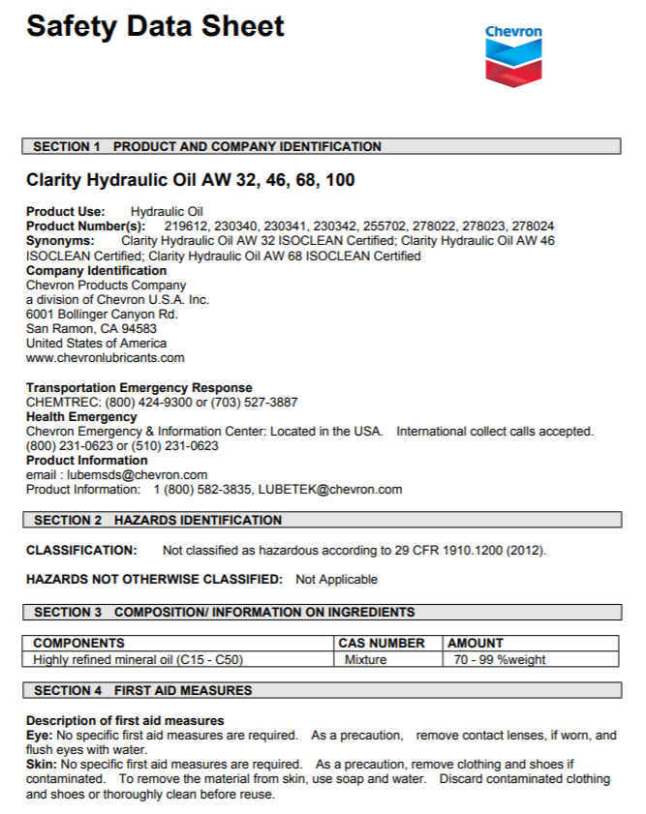
Dangers of Hydraulic Fluid

Hydraulic fluid is a very powerful and dangerous source of energy that can cause serious injury or death especially to the untrained worker. To the untrained eye, it looks like oil or another fluid found in equipment.
Hydraulic energy is a stored energy that can result in unexpected movement depending on the circumstances. To prevent the release of stored energy of hydraulics ensure equipment is blocked and the lock out/tag out procedure is followed before performing maintenance, repairs or adjustments.
A hydraulic line can break and spray flammable liquid, which can result in an explosion or fire. When a hose under pressure is disconnected, it can whip around and strike someone. If a line fails or is disconnected, the loss of fluid pressure can cause the equipment to collapse. This can result in serious injury or death, if a worker is under the equipment.
Gloves need to be worn when checking for leaks as well as a piece of cardboard used as an extension to the hand. Exposed hands when checking for leaks can result in hydraulic fluid being injected into the hand which can cause a serious infection which can lead to hand amputation.
It is very important to read the safety data sheets for specific hydraulic fluid as well as ensure that the correct hydraulic fluid is used for designate equipment. It is also important to ensure hoses, pipes, valves, filters and fittings are applied and used as per the manufacturer’s recommendations.
Jacks that use hydraulics must have limiting devices to prevent jacking them to high as well as a load limit marked on them in an obvious location and the limit followed to prevent equipment failure. Jacks are required to have an annual certification as per Part 7 Hoists & Mobile Equipment of the Occupational Health and Safety General Regulations. It is key to note, jacks are for lifting only, not holding. Ensure to block hoisted items once lifted.
Hydraulics can make light work of everyday work activities, but if not handled as per manufacturers specifications and safety data sheets, it can be deadly.

Dangers of Hydraulic Fluid – DISCUSSION RECORD

Agenda:
- What machines operated on farm use hydraulic oil?
- Is the SDS for the Hydraulic used on hand and up to date?
- Do you have a safe work practice or written work procedure for checking for hydraulic leaks?
Comments or safety concerns as a result of the discussion or observed since the last rally?
______________________________________________________________________________________________________________________________
Follow-up to concerns raised at previous rally?
______________________________________________________________________________________________________________________________
Action Items?
______________________________________________________________________________________________________________________________

Near Miss/Incidents/Unsafe Acts/Conditions to Report?
______________________________________________________________________________________________________________________________

Topics recommended for future Rallies: __________________________________________

Thank the rally members for their participation.
Quiz Answers: 1. T, 2. T, 3. a, 4.a

TEST YOUR KNOWLEDGE
1. It is very important to read the safety data sheets for specific hydraulic fluid used on farm.
True or False

2. Hydraulic energy is a stored energy that can result in unexpected movement depending on the circumstances. True or False
3. Which of the following help prevents the release of stored energy of hydraulics:
- Block & Lockout/Tagout of equipment
- Park on a flat surface
- Wear seatbelt
- All of the Above
4. Hydraulic Jacks are for ____________only, not __________.
- lifting, holding
- raising, lowering
- pushing, pulling
What would you do?
You see a puddle of what looks to be oil under the skid steer parked in the yard but you are not sure? What do you do next?
______________________________________________________________________________________________________________________________
Attendance RECORD
*This is to acknowledge that I understand and agree to actively participate in the safety meeting.
Print Name: | Signature:

