The Power of Generator Hazards
As farms become more and more automated and they depend on electricity to do their day to day chores, a backup supply of electricity is essential if there is a power outage. A back up power supply can be essential in sustaining life of livestock and plants by providing a power source for robotic milking systems for dairy producers to providing lights, heat and irrigation for greenhouse operations. Not only do generators sustain life on the farm they can also take life due to fire and carbon monoxide hazards.
Common causes of power outages in Nova Scotia are most often weather related such as heavy rain, freezing, rain, ice storms, heavy snow, flooding, and hurricane force winds.
Only fully-trained, qualified and authorized personnel should perform any work on generators and electrical systems. Generators can be wired directly into a building’s existing electrical system. Safeguards are in place to prevent surges. Some generators require manual start up when the power goes out. Only trained and competent workers should be in charge of manual start up.
Portable generators also are used for powering essential equipment during power outages, both in the home and on the farm. Improper installation and use can endanger cause serious injury or death.

Best Practice for Portable Generators:
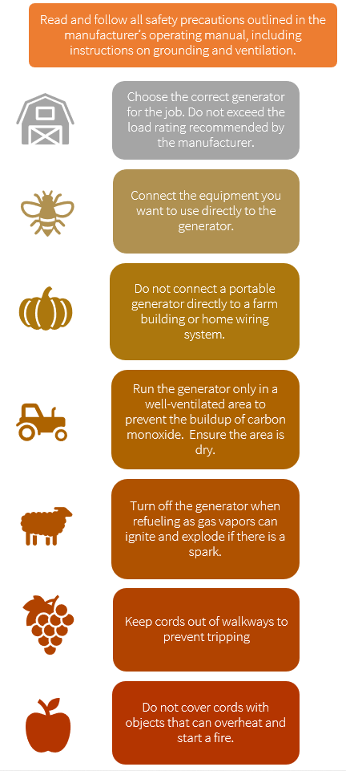

The Power of Generator Hazards – DISCUSSION RECORD
Agenda:
- Does the farm use generators as part of storm preparation or as a part of regular operating equipment on the farm?
- Are generators regularly maintained and tested throughout the year?
- Discuss common hazards of the farm specific generator make and model.
Comments or safety concerns as a result of the discussion or observed since the last rally?
______________________________________________________________________________________________________________________________
Follow-up to concerns raised at previous rally?
______________________________________________________________________________________________________________________________
Action Items?
______________________________________________________________________________________________________________________________

Near Miss/Incidents/Unsafe Acts/Conditions to Report?
______________________________________________________________________________________________________________________________

Topics recommended for future Rallies: __________________________________________

Thank the rally members for their participation.
Quiz Answers: 1. T, 2. T, 3. f, 4. b, 5. T
TEST YOUR KNOWLEDGE
1. As farms become more and more automated and they depend on electricity to do their day to day chores, a backup supply of electricity is essential if there is a power outage. True or False
2. Not only do generators sustain life on the farm they can also take life due to fire and carbon monoxide hazards. True or False
3. A back up supply of power may be used for the following tasks:
- Robotic Milking Systems
- Power Lighting
- Provide Heat
- Irrigate plants
- Keep Fridge/Freezer systems operating
- All of the Above
4. Only fully-trained, ____________ and authorized personnel should perform any work on generators and electrical systems.
- Mechanics
- Qualified
- Abled
5. Improper installation and use can endanger cause serious injury or death. True or False
Attendance RECORD
*This is to acknowledge that I understand and agree to actively participate in the safety meeting.
Print Name: | Signature:

