Forklift

Forklift Best Practice
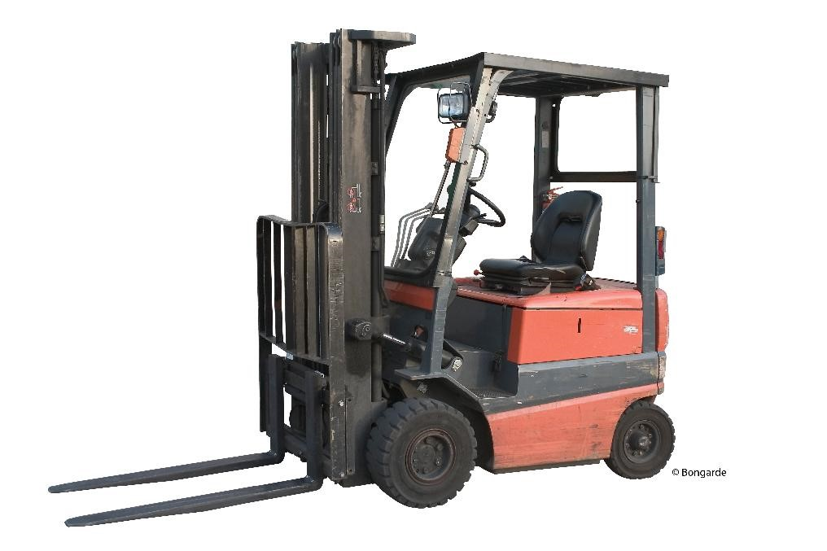
Forklifts, like tractors, can be the workhorses of the farm. Forklifts are a potential safety hazard as they move around workers, stacked materials, as well as on public roads while they move material from location to location. A forklift incident can cause an injury to the operators as well as other workers or the public, below are a few hints and tips for forklift operation.
This is not a complete list of safe operational practice as there are many different types of forklifts used on farm across the province.
- Read the owner’s manual to learn the safe best practices for the use of your particular forklift to prevent incident and injury on the farm.
- Know the Occupational Health and Safety requirements for Lift Trucks in Nova Scotia in Part 7, Sections 81 & 82.
- Develop a safe work practice for forklifts for the uses on your farm. Visit the Farm Safety Nova Scotia website to download and adapt a template.
- Do not operate a forklift unless you are trained and certified as a forklift operator. Farm Safety Nova Scotia offers forklift training at discounted rates through Safety Services Nova Scotia. Call 902-893-2293 or e-mail info@farmsafetyns.ca to book your training session today.
- Evaluate the mechanical and structural condition of your forklift, before use and document it. Visit the Farm Safety Nova Scotia Website for a sample pre-use checklist you can download and adapt for your particular forklift. Use the Forklift Operators Manual to help to adapt your checklist.
- Ensure load is secure before operating the forklift. Are the pallets in good condition do you know the rated load capacity for your forklift? Is the load capacity posted on the forklift in a visible area? A tipped load or a load too heavy for the forklift can injure other workers and the operator as well as can damage the forklift.
- Ensure load is evenly distributed and cannot become unstable. Keep the forklift's mast in a vertical position with a slight tilt backward and lift the load only to a height that will prevent the forks from dragging. If operating on uneven ground, lift the load slightly higher.
- Post clearance heights for the operator to act as a reminder of areas which may be of particularly low clearance.
- Consider walking the route to check for obstacles, obstructions, traffic, and overhead clearances that will pose a problem.
- Communication is key when operating a forklift around workers and with other traffic. Ensure workers and other operators know agreed upon signals and post signs in areas the forklift is operated.
- Report near misses or incidents immediately to implement corrective action to prevent future incidents.

Forklift – DISCUSSION RECORD

Agenda:
- Discuss the types of forklift on farm.
- Review who has formal forklift training.
- Review the pre-trip inspection process before using the forklift.
- Check maintenance records to see if it is up to date. Does maintenance meet manufacturers specifications listed in the owner’s manual?
Comments or safety concerns as a result of the discussion or observed since the last rally?
______________________________________________________________________________________________________________________________
Follow-up to concerns raised at previous rally?
______________________________________________________________________________________________________________________________
Action Items?
______________________________________________________________________________________________________________________________

Near Miss/Incidents/Unsafe Acts/Conditions to Report?
______________________________________________________________________________________________________________________________

Topics recommended for future Rallies: __________________________________________

Thank the rally members for their participation.
Quiz Answers: 1. T, 2. T, 3. d, 4.C

TEST YOUR KNOWLEDGE
1. Forklifts, like tractors, can be the workhorses of the farm. True or False
2. Forklifts are a potential safety hazard as they move around workers, stacked materials, as well as on public roads while they move material from location to location. True or False
3. Which of the following are best practice for forklift:
- Read owners’ manual
- Park with forks on ground
- Carry loads low.
- All of the Above
4. What Part of the Occupational Health and Safety requirements for Lift Trucks in Nova Scotia apply?
- Part 3
- Part 11
- Part 7
What would you do?
A worker was helping you unload a truck of fertilizer while you drive the forklift. He was checking for traffic. You can no longer see him.
______________________________________________________________________________________________________________________________
Attendance RECORD
*This is to acknowledge that I understand and agree to actively participate in the safety meeting.
Print Name: | Signature:

