FLAMMABLES AND COMBUSTIBLES LIQUIDS ON THE FARM

Flammable and combustible liquids are present on most farms such as gas and diesel fuel, solvents, cleaners, oxygen, acetylene and lubricants. When used and stored correctly the gases and liquids rarely cause an issue on the farm.
Being knowledgeable when it comes to common terms and key concepts related to flammable and combustible liquids is one of the best ways to protect yourself.
Flammable and combustible liquids include:
- liquids that can burn and classified by their flashpoints.
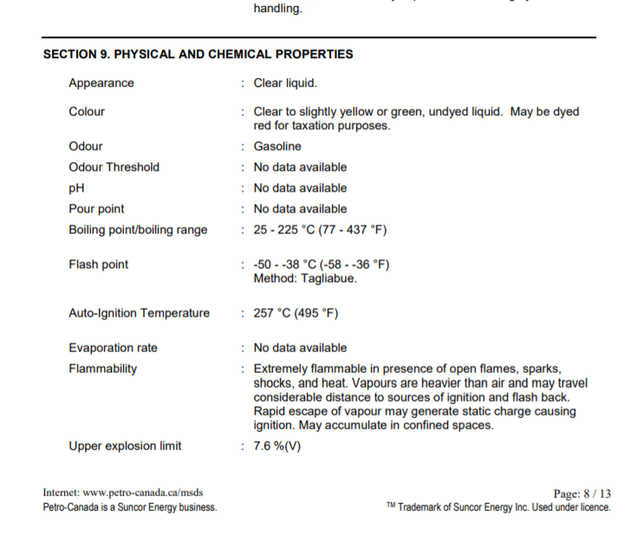
- have a flashpoint at or above 100F or 37.8C and below 200F or 93.3C.
The FLASHPOINT of a liquid is the lowest temperature that the liquid gives off enough vapor at the surface of the liquid to ignite. Knowing the flashpoint will tell you when conditions are best for them to ignite.
The AUTO-IGNITION TEMPERATURE is the temperature at or above which a material will spontaneously ignite without an external spark or flame. Most of the flammable and combustible liquids used on the farm have an auto-ignition temperature in the range of 572F or 300°C to 1022F or 550C.
It is the mixture of the vapours of flammable and combustible liquids that burn not the product themselves. Gasoline has a flashpoint of -40F or -40C, which means that even at temperatures as low as -40°F or -40°C, it gives off enough vapor to form a burnable mixture in air.
In the sample Safety data sheet shown the flashpoint is -50 to -38C
The LOWER EXPLOSIVE LIMIT (LEL) is the minimum concentration of a gas or vapor necessary for it to combust in air is defined as the lower explosive limit or lower flammable limit (LEL or LFL). This is expressed as a percentage.
The UPPER EXPLOSIVE LIMIT (UEL) is the maximum concentration of a gas or vapor that will allow it to burn in air is the upper explosive limit or upper flammable limit (UEL or UFL). This is also expressed as a percentage.
Every combustible gas or vapor has a specific range of fuel to oxygen mixture during which it will ignite. The flammable range for every gas or vapor is the range between the LEL and UEL.
The take away, read the Safety Data Sheets for your Flammable and Combustible liquids on the farm to know the correct storage conditions and temperatures to prevent fires and explosions.

FLAMMABLES AND COMBUSTIBLES LIQUIDS ON THE FARM – DISCUSSION RECORD

Agenda:
- Are flammable & combustible liquids used on farm?
- Make a list of the flammables & Combustibles used.
- Do you have up to date safety data sheets for each of the products used?
- Are flammable & combustible liquids stored near sources of ignition?
Comments or safety concerns as a result of the discussion or observed since the last rally?
______________________________________________________________________________________________________________________________
Follow-up to concerns raised at previous rally?
______________________________________________________________________________________________________________________________
Action Items?
______________________________________________________________________________________________________________________________

Near Miss/Incidents/Unsafe Acts/Conditions to Report?
______________________________________________________________________________________________________________________________

Topics recommended for future Rallies: __________________________________________

Thank the rally members for their participation.
Quiz Answers: 1. T, 2. T, 3. a, 4.a

TEST YOUR KNOWLEDGE
1. The FLASHPOINT of a liquid is the lowest temperature that the liquid gives off enough vapor at the surface of the liquid to ignite. True or False
2. Flammable and combustible liquids are present on most farms such as gas and diesel fuel, solvents, cleaners, oxygen, acetylene and lubricants.
True or False
3. The AUTO-IGNITION TEMPERATURE is the temperature ___________which a material will spontaneously ignite without an external spark or flame.
- at or above
- at or below
4. The Flash Point for gasoline is ____________.
- -40F or -40C
- -50 C to -38C
- -40F or -30C
What would you do?
A new supply order has arrived at the farm. You notice a few chemicals in the order that you have not seen before. You are tasked to put the chemicals away? What should you do first?
Attendance RECORD
*This is to acknowledge that I understand and agree to actively participate in the safety meeting.
Print Name: | Signature:

