Farming Under UV Rays

Working on the farm in the spring, summer, and fall not only comes with the heat of the sun blaring down on you, but also exposure to UV Rays. It may seem like a good idea to wear a tank top and shorts, but you may want to consider proper skin protection to avoid serious skin damage.
UV Rays can cause aging skin, cataracts & other eye problems as well as skin cancer, melanoma.
To protect yourself from UV rays, consider your risk of exposure:
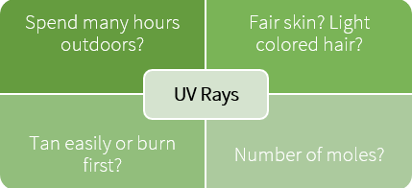

Examine your body regularly for early detection of skin cancer. Caught early it can almost always be cured. Early warning signs may include a spot on your skin that changes in size, color or shape over a period of one month to one or two years.
Look for a red scaly patch that is outlined, a waxy pale pearly knob, or a sore that doesn’t heal.
The most serious, melanoma, often begins as a small growth looking like a mole. If you find an unusual skin change, see your doctor.

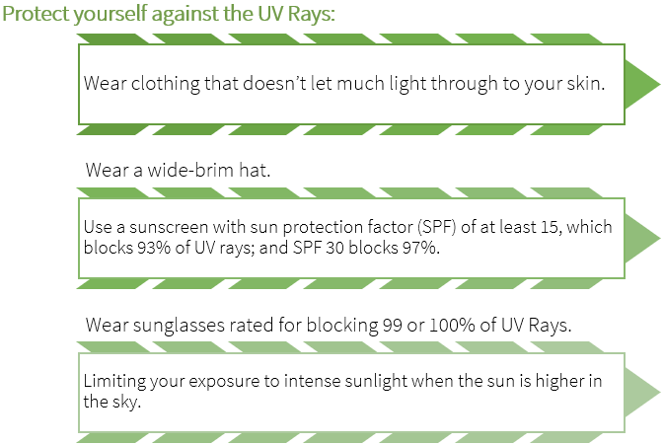

Sun Safety in the Workplace
According to the national sun survey (2006), 29% of Atlantic Canadians age 16 - 64 have occupations that require them to work outdoors. Of these outdoor workers, 41% spend four or more hours outdoors daily. These statistics suggest a significant number of Nova Scotians may be subject to overexposure to Ultra Violet (UV) radiation, the number one risk factor for skin cancer, while at work.
Visit the Sun Safety Nova Scotia website to find tools and resources to build a Sun Safety at Work: A Management Systems Approach to Occupational Sun Safety program for the farm.

Farming Under UV Rays – DISCUSSION RECORD
Agenda:
- Discuss UV exposure no your farm.
- Who provides protection against UV?
- Do you monitor your skin for UV damage such as unusual skin change?
Comments or safety concerns as a result of the discussion or observed since the last rally?
______________________________________________________________________________________________________________________________
Follow-up to concerns raised at previous rally?
______________________________________________________________________________________________________________________________
Action Items?
______________________________________________________________________________________________________________________________

Near Miss/Incidents/Unsafe Acts/Conditions to Report?
______________________________________________________________________________________________________________________________

Topics recommended for future Rallies: __________________________________________

Thank the rally members for their participation.
Quiz Answers: 1. T, 2. T, 3. d, 4.b
TEST YOUR KNOWLEDGE
1. UV Rays can cause aging skin, cataracts & other eye problems as well as skin cancer, melanoma. True or False

2. Early warning signs may include a spot on your skin that changes in size, color or shape over a period of one month to one or two years.
True or False
3. Which of the following are symptoms of UV damage to the skin?
- Red scaly patch of skin
- A waxy pearly knob
- A sore that doesn’t heal
- All of the Above
4. What percentage of Atlantic Canadians age 16 - 64 have occupations that require them to work outdoors.
- 95%
- 29%
- 35%
Attendance RECORD
*This is to acknowledge that I understand and agree to actively participate in the safety meeting.
Print Name: | Signature:

