Farming In The Heat
Heat stress occurs when the body has to work too hard to cool off. The body's core temperature gets too high for the body to cool off quickly enough.
Heat stress:
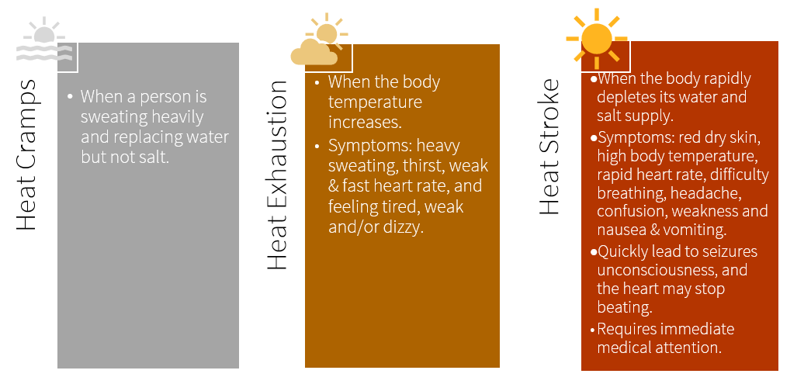
How to Prevent Heat Stress:
- Heat cramps - when a person is sweating heavily and replacing water but not salt.
- Even though you are short on labour and have a mountain of work to do, ensure to take rest breaks.
- If possible, organize the heavy work for the cooler parts of the day such as morning and evening and do less laborious work in the heat of the day.
- Drink water frequently. Don't wait until you are thirsty to drink.
- Eat regular, light meals throughout the day. Replace salt if you are sweating a lot. Ask your doctor how.
- Take your time when moving from a cool area to a hot one, such as leaving an air-conditioned vehicle, equipment, or tractor cab. Your body needs time to get used to the temperature.
- Dress in loose, comfortable light-colored clothing made of light fabrics such as cotton. Cotton cools the body 200 times faster when it is wet than any other fabric.
- Layer your clothing so you can add and take off items of clothing as the temperature changes.
- Wear a hat with a wide brim when working under the sun.
- In humid conditions, take frequent breaks as it takes longer for the sweat to evaporate to cool the body.
- If taking medication should check with a pharmacist to see if you are more susceptible to heat illness.
- Train workers on the signs and symptoms of heat stress and how to mitigate the hazard.
Treating Heat Stress:
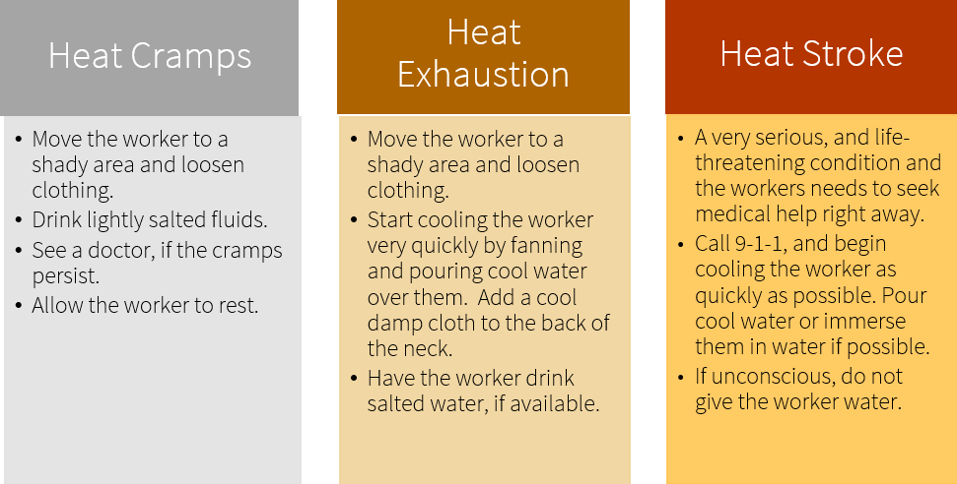
Farming In The Heat – DISCUSSION RECORD
Agenda:
- Discuss farm tasks that may result in heat stress if preventative measures are not in place.
- How do you cool it in the heat?
- Are you drinking enough water?
- What are you wearing in the heat while working?
- Review how to recognize signs and symptoms of heat stress.
Comments or safety concerns as a result of the discussion or observed since the last rally?
______________________________________________________________________________________________________________________________
Follow-up to concerns raised at previous rally?
______________________________________________________________________________________________________________________________
Action Items?
______________________________________________________________________________________________________________________________

Near Miss/Incidents/Unsafe Acts/Conditions to Report?
______________________________________________________________________________________________________________________________

Topics recommended for future Rallies: __________________________________________

Thank the rally members for their participation.
Quiz Answers: 1. T, 2. T, 3. d, 4.T
TEST YOUR KNOWLEDGE
1. Heat stress occurs when the body has to work too hard to cool off. True or False

2. Take your time when moving from a cool area to a hot one, such as leaving an air-conditioned vehicle, equipment, or tractor cab. Your body needs time to get used to the temperature. True or False
3. Which of the following are symptoms of heat stroke?
- Red hot dry skin
- Difficulty breathing
- High body temperature
- All of the Above
4. Layer your clothing so you can add and take off items of clothing as the temperature changes.
Wear a hat with a wide brim when working under the sun. True or False
What would you do?
A worker who was working beside you has slowed down & doesn’t look well. They were sweating before but not anymore. What would you do?
______________________________________________________________________________________________________________________________
Attendance RECORD
*This is to acknowledge that I understand and agree to actively participate in the safety meeting.
Print Name: | Signature:

