Chainsaw Hazards & Prevention

Chainsaws can be used on farm for various tasks such as cutting firewood, topping fence posts, woodlot management and felling large trees. Chainsaws can be a valuable tool on the farm but can also be a very dangerous one too when the operator has not been formally trained, doesn’t understand the hazards associated with its’ use, or is and inexperienced operator.
Three main hazards are associated with using a chainsaw are noise, vibration and cuts.
When a farmer is exposed to noise as loud as a chainsaw, hearing loss can occur. Damage to hearing is permanent and can become worse over time with continuous exposure. You can prevent hearing loss while using this powerful tool by simply putting on hearing protection that is adequate for the decibel level of the chainsaw you use. Ensure the hearing protection meets the CSA Standard for hearing protection CSA Z94.2 and fits properly.
Over time, chainsaw vibration can cause circulatory problems in your fingers, hands, and arms. To mitigate the risk of vibration, ensure that the saw is equipped with vibration dampening devices, the saw is sharp, you have a firm but not a tight grip, and you are warm while working.
Cuts are the most common injuries suffered by chainsaw users and those working around chainsaws. Workers can suffer from minor injuries when filing a chain to an amputation from kickback or another worker working too close to the user.
Download the Safe Work Practice for Chainsaws from the Farm Safety Nova Scotia Website and adapt and use as your own to help prevent incident and injury on farm while using this valuable yet dangerous tool.
Here are a few hints & tips for safe chainsaw use:
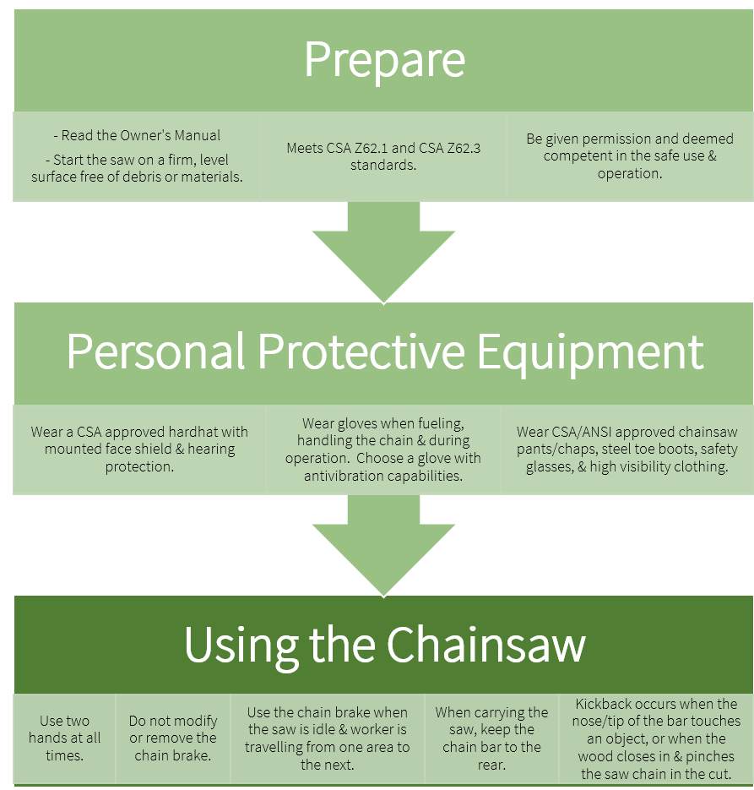

Chainsaw Hazards & Prevention – DISCUSSION RECORD

Agenda:
- What tasks are performed on farm with a chainsaw?
- Have workers received formal chainsaw training?
- Is the correct PPE available and worn while using the chainsaw?
Comments or safety concerns as a result of the discussion or observed since the last rally?
______________________________________________________________________________________________________________________________
Follow-up to concerns raised at previous rally?
______________________________________________________________________________________________________________________________
Action Items?
______________________________________________________________________________________________________________________________

Near Miss/Incidents/Unsafe Acts/Conditions to Report?
______________________________________________________________________________________________________________________________

Topics recommended for future Rallies: __________________________________________

Thank the rally members for their participation.
Quiz Answers: 1. T, 2. T, 3. d, 4. b, 5. T
TEST YOUR KNOWLEDGE
1. Three main hazards are associated with using a chainsaw are noise, vibration and cuts.
True or False
2. Chainsaws can be a valuable tool on the farm but can also be a very dangerous one too when the operator has not been formally trained, doesn’t understand the hazards associated with its’ use, or is and inexperienced operator. True or False
3. Which of the following PPE should be worn when operating a chainsaw:
- CSA approved hard with face shield and hearing protection.
- Wear CSA/ANSI approved chainsaw pants/chaps, steel toe boots, safety glasses, & high visibility clothing.
- Antivibration Gloves
- All of the Above
4. Damage to hearing is ________________ and can become worse over time with continuous exposure.
- Temporary
- Permanent
- Not so bad
5. Farm Safety Nova Scotia has a Safe Work Practice for Chainsaws that can be adapted and used as your own to help prevent incident and injury. True or False
Attendance RECORD
*This is to acknowledge that I understand and agree to actively participate in the safety meeting.
Print Name: | Signature:

