How to Access CSA Standards Referenced in OHS Legislation!
Have you noticed that when browsing through the Nova Scotia Occupational Health and Safety (OHS) Act and Regulations, there is reference to the Canadian Standards Association (CSA) or CSA Group for:

- Portable Ladders
- Protective Footwear
- Eye and Face Protectors
- High Visibility
- Fall Protection
- Chainsaws
- Roll Over Protective Structures for Agriculture (ROPS)
- Lift Trucks
- Propane Storage and Handling
- Portable Containers for Gasoline and Other Petroleum Fuels
- And more…

When a CSA Standard is referenced in the OHS Act or Regulations, the employer should follow and use the information found in the CSA Standard. Go to the CSA Communities website to view CSA Standards referenced in OHS legislation. For printed copies of the CSA Standards, purchase the CSA Standard on the website. Once purchased, it can be downloaded and printed or mailed to the address provided.
To view and purchase standards, create a CSA communities account. Click the link for CSA Communities and add your e-mail address under “Don’t Have an Account.” Follow the prompts to create the account. Click here for a PDF with instructions on getting started. Once signed in, you will see the Welcome page below. To find the CSA Standard you are looking for, click the orange box labelled “View Standards.”
A window will open with icons to the left, scroll until you see the blue icon that says “OHS Standards” and click “View Access.” See screen shot below.
A new window will open listing each of the provinces and territories. Click on “Nova Scotia” to view the CSA Standards referenced in the Nova Scotia Occupational Health and Safety Act & Regulations.
All of the CSA Standards referenced for Nova Scotia are listed. It is easier to scroll by looking for the numbered standard. In this example, we are going to take a look at protective footwear. Scroll to Z195. To the right, click “View” to open the standard information page.
It opens up in a window similar to a PDF. Navigate by page number, adjust the size of the window, and how you want to view the pages. If there is only a small portion of the standard you are interested in, take a screen shot of the browser window and print the screen shot of the page.
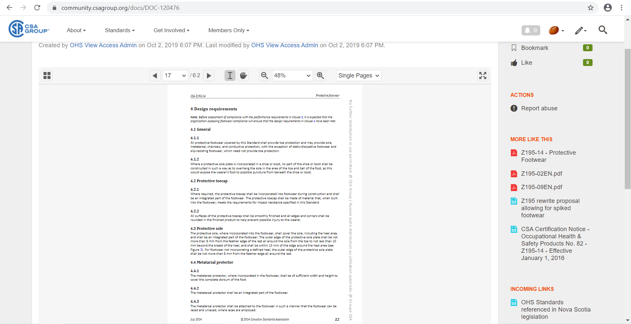

.
How to Access CSA Standards Referenced in OHS Legislation! – DISCUSSION RECORD
Agenda:
- What CSA Standards apply to the work you do on the farm?
- Demonstrate how to access the standards using CSA communities using the instruction in this meeting.
Comments or safety concerns as a result of the discussion or observed since the last rally?
______________________________________________________________________________________________________________________________
Follow-up to concerns raised at previous rally?
______________________________________________________________________________________________________________________________
Action Items?
______________________________________________________________________________________________________________________________

Near Miss/Incidents/Unsafe Acts/Conditions to Report?
______________________________________________________________________________________________________________________________

Topics recommended for future Rallies: __________________________________________

Thank the rally members for their participation.
Quiz Answers: 1. T, 2. T, 3. e, 4. b,
TEST YOUR KNOWLEDGE
1. When a CSA Standard is referenced in the OHS Act or Regulations, the employer must then follow and use the information found in the CSA Standard. True or False
2. To view and purchase standards CSA Standards referenced in OHS Legislation, you will need to create a CSA Communities account. True or False
3. CSA Standards reference in OHS Act & Regulations may include:
- Personal Protective Equipment (PPE)
- Ladders
- Chainsaws.
- Propane Storage and Handling
- All of the Above
4. To find the CSA Standard you are looking for, click the _____________ box labelled “View Standards.”
- Blue
- Orange
- Brown
Attendance RECORD
*This is to acknowledge that I understand and agree to actively participate in the safety meeting.
Print Name: | Signature:

