Hand washing station in the field
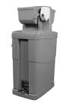
Hand Sanitizer may not be effective in killing all germs on the hands when the hands are soiled, contaminated with chemicals or pesticides, oily, or greasy. The only alternative is to wash hands thoroughly with soap and water for at least 20 seconds to eliminate the germs. After washing hands, then use hand sanitizer to disinfect the hands.
Companies who offer portable toilets may also offer portable hand washing stations on a contractual basis or for purchase. The water is pumped using a foot pedal which gives a hygienic source for hand washing. Use disposable towels instead of laundered towels for wiping hands. Laundered towels can become contaminated if hands are not washed thoroughly and if the towel is touched before the hands are washed.
Professional hand washing stations can come at an expense. There are less expensive alternatives to creating hand washing stations in the field as well.
For example:
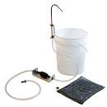
- Hands-free hand wash stations are available at camp supply stores and online.
- Use a gravity water tank with a tap in which workers can wash their hands underneath the tap. Supply ample amount of soap for cleansing and disposable towels for drying hands. Coach workers to shut off the tap with disposable towels after drying hands.
- Use a garden hose connected to a tank or well. Prop the hose up so water can run hands free and use it like the gravity water tank above.
Below are a few hand washing prototypes made by the North Carolina State University. Click the web link below to see the entire document and how to build your own. (https://ncfreshproducesafety.ces.ncsu.edu/wp-content/uploads/2014/03/Hand-washing-unit-handout.pdf?fwd=no)
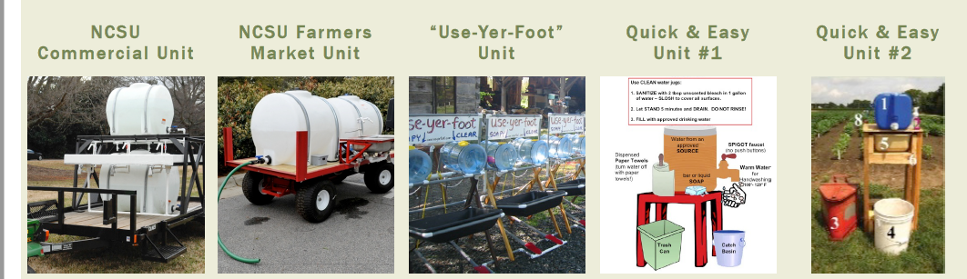

Reference:
- https://www.cdc.gov/handwashing/show-me-the-science-handwashing.html
- https://www.farmsafetyns.ca/covid19/handsanitizer
- https://ncfreshproducesafety.ces.ncsu.edu/wp-content/uploads/2014/03/Hand-washing-unit-handout.pdf?fwd=no

